USER MANUAL
SAP MIRO Wizard
A simple, step-by-step guide to filling the SAP MIRO Excel file from a Bill of Entry in Canofy

Document Title | SAP MIRO Wizard – User Manual
Application | Canofy
Workspace | Custom Belimo

Table of Contents
1. Introduction 3
1.1 Purpose of This Manual 3
1.2 Key Words Used in This Manual 3
1.3 How the Wizard Works 4
2. Before You Begin 5
2.1 Mandatory Pre-Check: Verify Part Codes in the BOE 5
2.2 Open the Bill of Entry 6
2.3 Review the Part Code of Every Line Item 8
2.4 Correct a Wrong Part Code 9
3. Opening the Wizard 11
4. Step 1 — Upload 12
4.1 Fields on This Screen 13
4.2 Select the Bill of Entry 14
4.3 Prepare and Upload the SAP MIRO Template 14
4.4 Upload the Invoice PDF (Optional) 15
4.5 Enter the PO Number (Optional) 16
4.6 Continue and Analyze 16
5. Step 2 — Review 17
5.1 Read the Summary 17
5.2 Review the Material List 18
5.3 Understand the Status 18
5.4 Generate the Output 18
6. Step 3 — Download 20
6.1 Read the Result 20
6.2 Download the Workbook 21
6.3 Start a New Process 21
7. Understanding the Output Workbook 22
7.1 SAP MIRO Matched Sheet 22
7.2 Summary Log Sheet 22
7.3 Invoice Extracted Data Sheet 23
8. Checking and Fixing Remarks 24
8.1 Aggregation Detected 24
8.2 Duplicate – Unresolved (Flagged) 24
8.3 Quantity Mismatch 24
8.4 Product Not Found (Unmatched) 25
9. Troubleshooting 26
10. Best Practices 27
Quick Reference 27

1. Introduction
The SAP MIRO Wizard helps you fill the SAP MIRO Excel file for one shipment, without typing the duty values by hand. You select the Bill of Entry (BOE) in Canofy, upload your SAP MIRO Template, and (if you have it) the supplier invoice PDF. The wizard reads the BOE line items from Canofy, matches every material in your template, and fills the duty columns for you.
In short: one BOE + one template in → one ready SAP MIRO workbook out. You only need to check the lines that the wizard marks for review.

1.1 Purpose of This Manual
This manual explains every screen of the wizard, what each field and button does, what each status and remark means, and what to do when a material is not matched.

1.2 Key Words Used in This Manual
Word | Meaning (in simple words)
BOE | Bill of Entry. The customs record of the shipment in Canofy. It holds every item, its quantity and the duty values (for example BE-00015, BE number 2666385).
SAP MIRO | The SAP step where the customs duty of the shipment is posted. The wizard prepares the Excel file used for this step.
SAP MIRO Template | Your Excel file with the list of materials to post. You fill the material, quantity and particular. The wizard fills the rest.
Material Code | The item code (for example 01APS-10R). It must be the same in the template and in the BOE.
Part Code | The material code of a line item in the BOE (PART CODE column on the Item tab). The wizard compares it with the SAP Material Code in your template.
Particular | The type of duty on the line, for example IN Basic customs, Social Welfare Surcharge or Customs Sec H CESS. Each material has one line for each particular.
Invoice PDF | The supplier invoice (for example BELIMO invoice 91608363). It is used to find the correct PO number for each material. Optional.
PO Number | Purchase Order number (for example 1766754). It can come from the invoice or you can type it. Optional.
CQTY | Customs quantity. The quantity of a material as written in the BOE in Canofy.
Assessable Value | The value of the goods on which customs duty is calculated.
IGST | Integrated GST charged on the import. The wizard fills the IGST Rate and IGST Amount.
Output Workbook | The Excel file you download in Step 3. It has the filled SAP MIRO sheet, a Summary Log and the invoice data.

1.3 How the Wizard Works
The wizard has three steps. The bar at the top of the page always shows where you are: the current step is shown in black, and finished steps turn green with a tick mark.
STEP 1  Upload | STEP 2  Review | STEP 3  Download
Select the BOE, upload the template, invoice PDF and PO Number | Check the matching result for every material | Download the filled SAP MIRO workbook

2. Before You Begin
Please check these points before you start. This saves time and avoids errors later.
CHECKLIST
✓ The Bill of Entry (BOE) for this shipment is already created in Canofy, with all its items and duty values.
✓ The Logistics team has checked and corrected the Part Code of every line item in the BOE (see Section 2.1).
✓ You have the SAP MIRO Template in Excel format, with the same column headings as the standard template.
✓ In the template, SAP Material Code, SAP In Qty and Particular are filled for every line. These three columns are mandatory.
✓ The material codes in the template are written exactly like in the BOE (no extra spaces, no spelling changes).
✓ If the supplier is BELIMO, you have the invoice PDF ready. For other suppliers, keep the PO Number ready instead.
✓ You have permission to open the Custom Belimo workspace in Canofy.

NOTE
The wizard does not change anything in Canofy. It only reads the BOE and creates a new Excel file for you. Your uploaded template is also not changed; the result is saved as a new file.

2.1 Mandatory Pre-Check: Verify Part Codes in the BOE
RESPONSIBLE TEAM  Logistics Team | WHEN TO DO IT  After the BOE is created, before the wizard is used

The SAP MIRO Wizard finds each material by comparing the SAP Material Code in your template with the PART CODE of each line item in the BOE. If a Part Code in the BOE is wrong, incomplete or has an extra space, the wizard cannot find that material. The line is then shown as Unmatched (Product Not Found) and its duty values are not filled.
MANDATORY – LOGISTICS TEAM
The Logistics team must check the Part Code of every line item in the BOE before anyone runs the SAP MIRO Wizard.
Give special attention to lines where the product was not matched (Is Part Code Match = No).
This is a manual check. The system does not correct Part Codes by itself.

The pre-check has three short parts:
Part | Task | Section
A | Open the Bill of Entry | 2.2 – find the BOE and confirm it is the correct shipment
B | Review every Part Code | 2.3 – check each line on the Item tab
C | Correct wrong Part Codes | 2.4 – edit the line, remove spaces, save the BOE

2.2 Open the Bill of Entry
- Log in to Canofy.
- Click the search bar at the top (or press Ctrl + G), type Bill of Entry and open the Bill of Entry list (marker 1).
- In the BE No filter box, type the BE number of the shipment, for example 6471878 (marker 2).
- Click the BOE in the list to open it (marker 3).
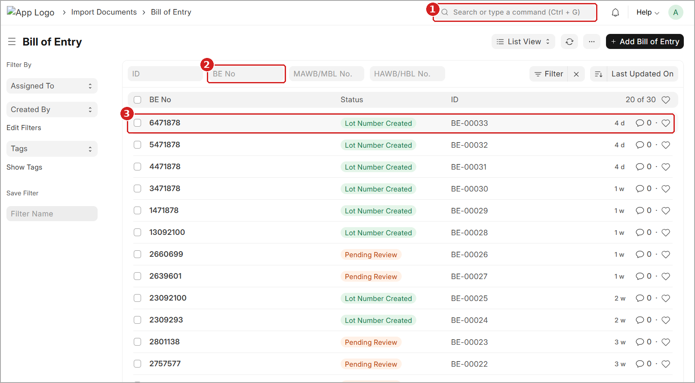
Figure 1: Bill of Entry list – searching the BOE by BE number
1 Search bar – type Bill of Entry to open the list (shortcut Ctrl + G).
2 BE No – type the BE number of the shipment here.
3 BOE row – click the correct BOE to open it. The ID (for example BE-00033) is shown on the right.

The BOE opens on the Details tab. Before you change anything, confirm that this is the correct shipment.
- Check the BE number in the page title (marker 1) and in the BE No field (marker 2). Both must be the BE number of your shipment.
- Click the Item tab (marker 3).
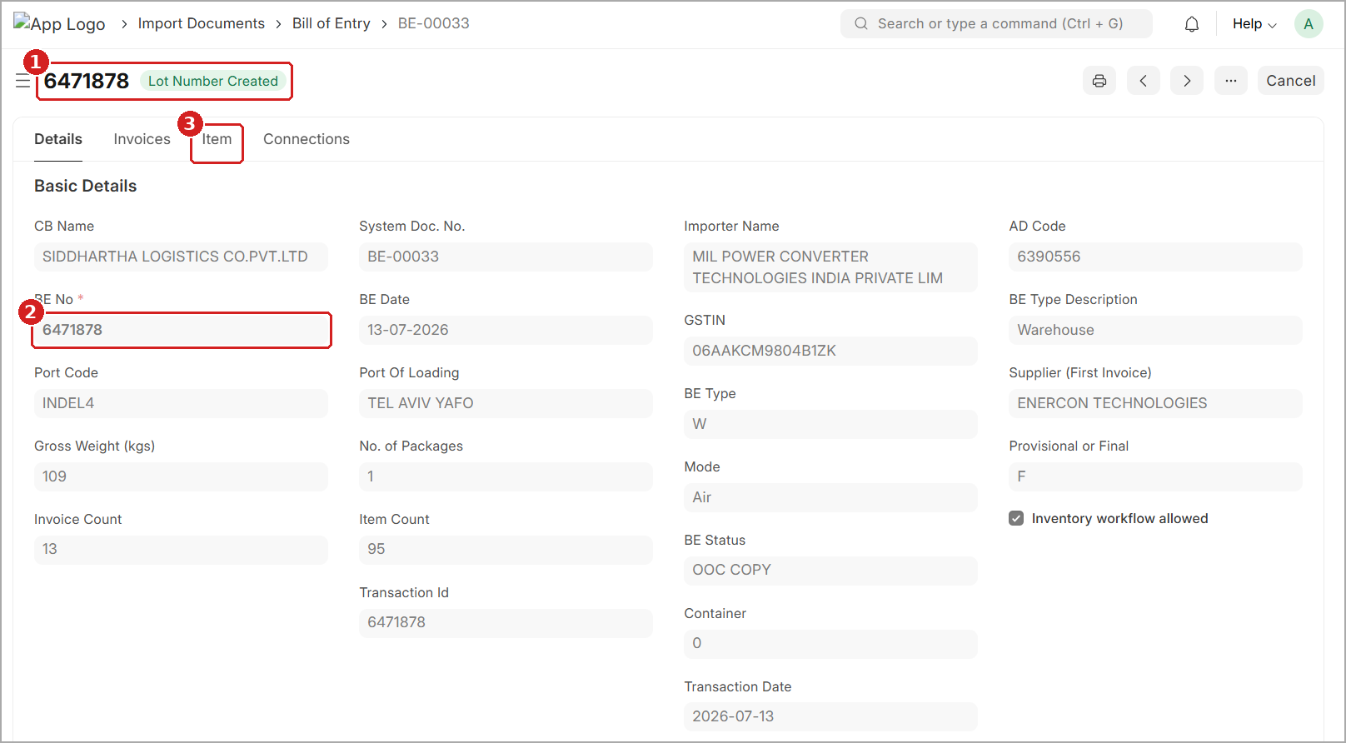
Figure 2: BOE Details tab – confirm the BE number, then open the Item tab
1 Page title – the BE number and status of the BOE.
2 BE No – must be the same as the BE number of your shipment.
3 Item tab – opens the list of all line items of the BOE.

2.3 Review the Part Code of Every Line Item
The Item tab lists every line item of the BOE. Check the lines one by one, from the first row to the last. Scroll down to the end of the table, and if the table has more than one page, check every page.
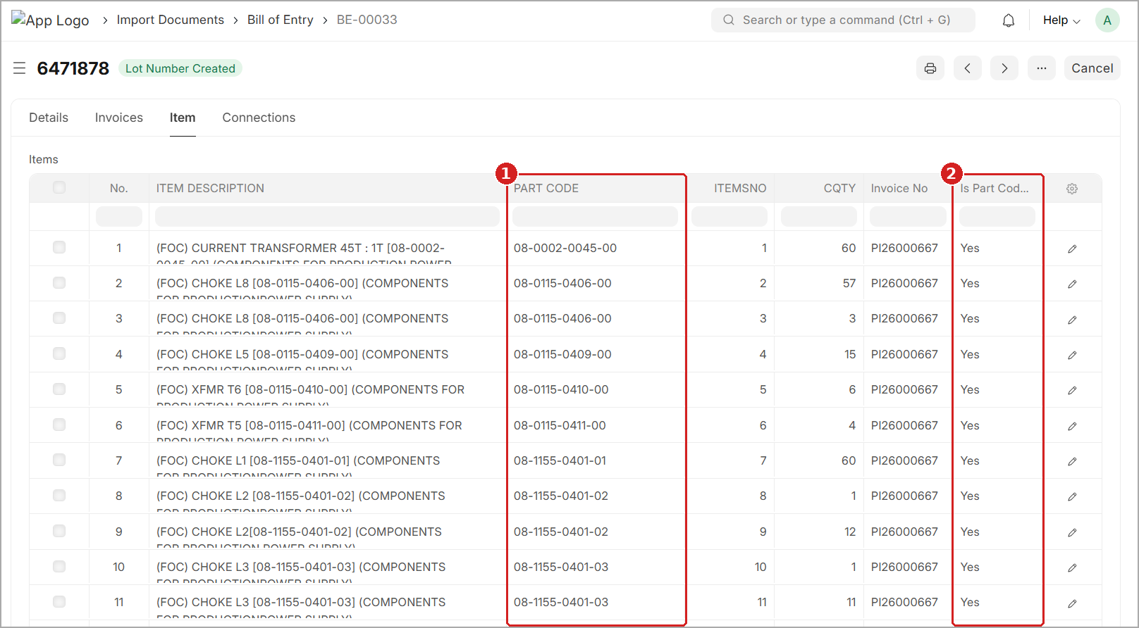
Figure 3: Item tab – PART CODE and Is Part Code Match columns
1 PART CODE – the code the wizard uses to find the material. It must be correct on every line.
2 Is Part Code Match – Yes means the Part Code was matched to a product. No means it was not matched – check these lines first.

A Part Code is correct only when it passes all the checks below:
Check | Correct | Wrong (example)
No spaces | 08-0002-0045-00 | “08-0002-0045-00 ” (space at the end), 08 -0002-0045-00 (space inside)
Same as the code in the Item Description | 08-0115-0406-00 | 08-0115-0460-00 (digits swapped)
Same dashes and format | 08-1155-0401-02 | 081155040102 (dashes missing)
Letters and numbers not mixed up | 01APS-10R | 0IAPS-1OR (letter I for 1, letter O for 0)
Not empty | A code on every line | PART CODE left blank

TIP
The correct Part Code is usually written inside square brackets [ ] in the ITEM DESCRIPTION, for example [08-0002-0045-00]. Use it, together with the supplier invoice, to confirm the code.

2.4 Correct a Wrong Part Code
- To find a line quickly, type in the empty filter boxes above the first row (marker 1). For example, type a part code under PART CODE, or type No under Is Part Code Match to show only the lines that were not matched.
- Click the Edit icon (pencil) at the end of the row (marker 2). The line item opens.
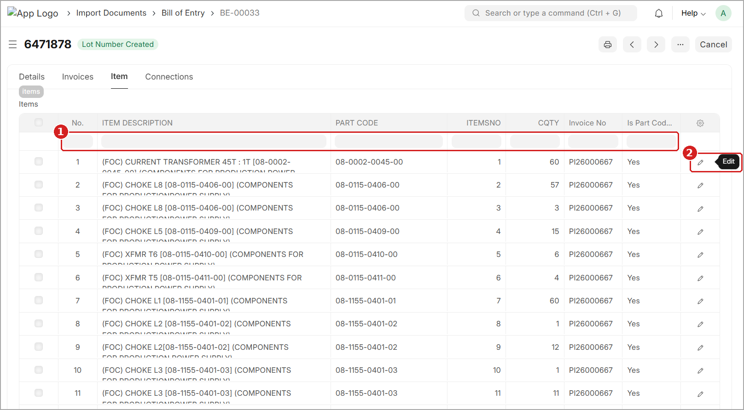
Figure 4: Item tab – filter boxes and the Edit icon of a line
1 Filter boxes – type here to show only the lines you need.
2 Edit – opens the line item so you can correct it.

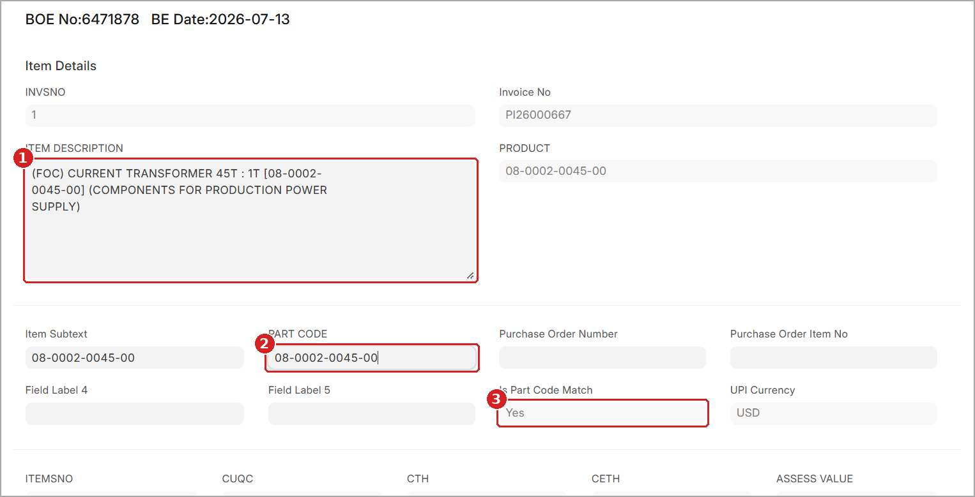
Figure 5: Line item form – correct the PART CODE
1 ITEM DESCRIPTION – shows the correct code inside square brackets [ ].
2 PART CODE – type the correct code here, with no spaces.
3 Is Part Code Match – shows whether the line was matched (Yes / No).

- Read the code inside the square brackets in ITEM DESCRIPTION (Figure 5, marker 1). This is the correct Part Code.
- Click the PART CODE field (Figure 5, marker 2). Delete the old value and type the correct code, with no spaces before, inside or after it.
- Close the line item and save the BOE: press Ctrl + S, or click Update (or Save) at the top right.
- Repeat steps 1 to 5 for every line that has a wrong Part Code.
WARNING
Type the Part Code exactly. Do not copy it from Excel or email – copied text often carries a hidden space at the end.
During this check, change only the PART CODE. Do not change quantities, duty values or any other field.

PRE-CHECK COMPLETE – SIGN-OFF BY LOGISTICS TEAM
✓ Every line item on the Item tab has been reviewed (for example all 95 items of BE 6471878).
✓ Every PART CODE is filled, correct and has no spaces.
✓ Every line that showed Is Part Code Match = No has been checked and corrected.
✓ The BOE has been saved after the corrections.
✓ The team that runs the SAP MIRO Wizard has been told that the BOE is ready.

3. Opening the Wizard
GOAL OF THIS STEP  Open the SAP MIRO Wizard | BUTTON TO MOVE ON  SAP MIRO Wizard link

The wizard is in the Custom Belimo workspace.
- Log in to Canofy.
- In the left menu, under PUBLIC, click Custom Belimo (marker 1).
- In the Quick Access section, click SAP MIRO Wizard (marker 2).
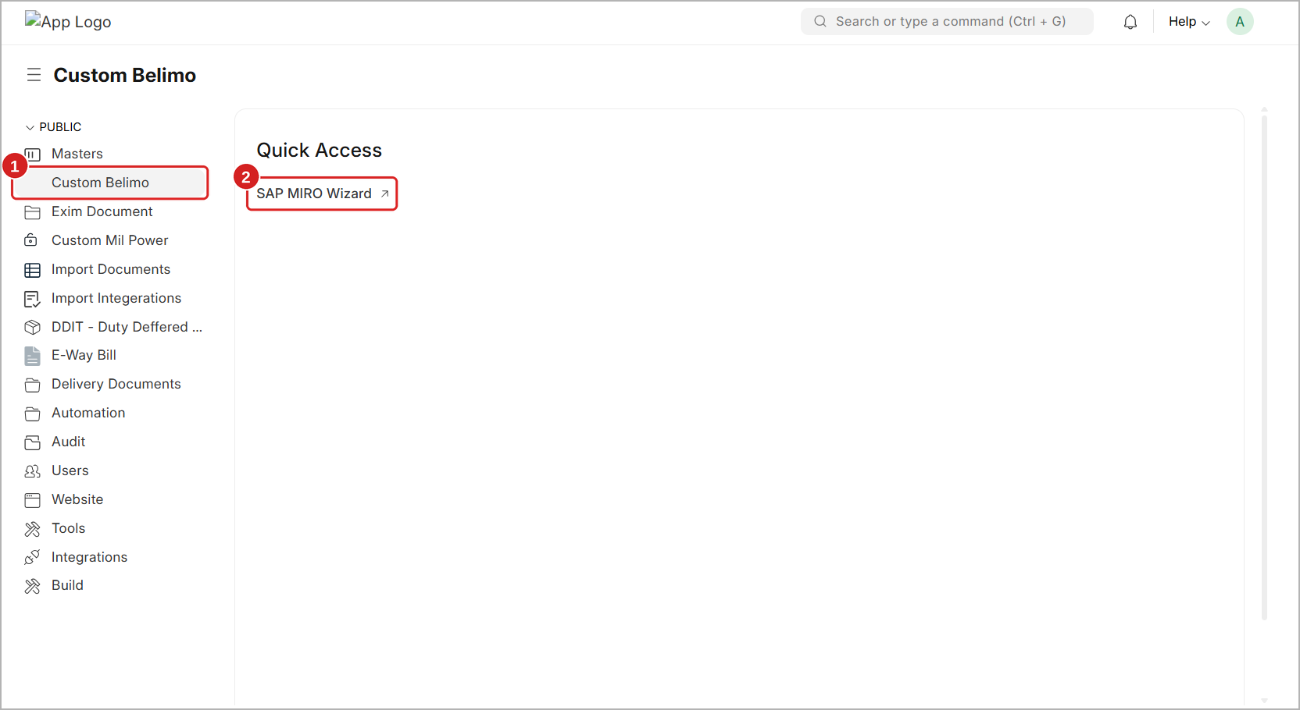
Figure 6: Custom Belimo workspace – SAP MIRO Wizard link in Quick Access
TIP
You can also type SAP MIRO Wizard in the search bar at the top (Ctrl + G) and open it from there.

4. Step 1 — Upload
GOAL OF THIS STEP  Select the BOE and upload your documents | BUTTON TO MOVE ON  Continue & Analyze →

The wizard opens on Step 1. Here you tell the wizard which shipment you are working on and give it the files it needs.
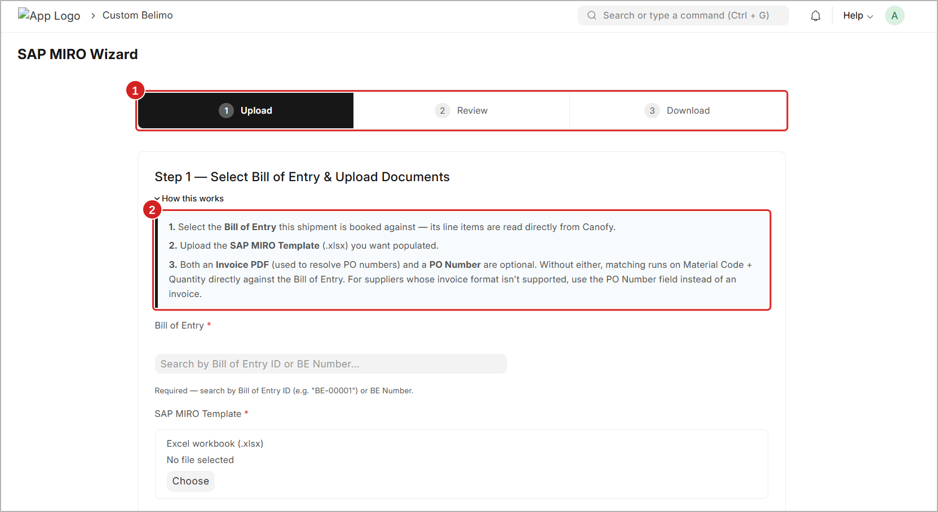
Figure 7: Step 1 – Upload screen with the step bar and the help box
1 Step bar – shows the three steps. Upload is the current step (black).
2 How this works – a short help box. Click it to open or close it.

4.1 Fields on This Screen
Scroll down to see all the fields. Fields with a red star (*) are required.
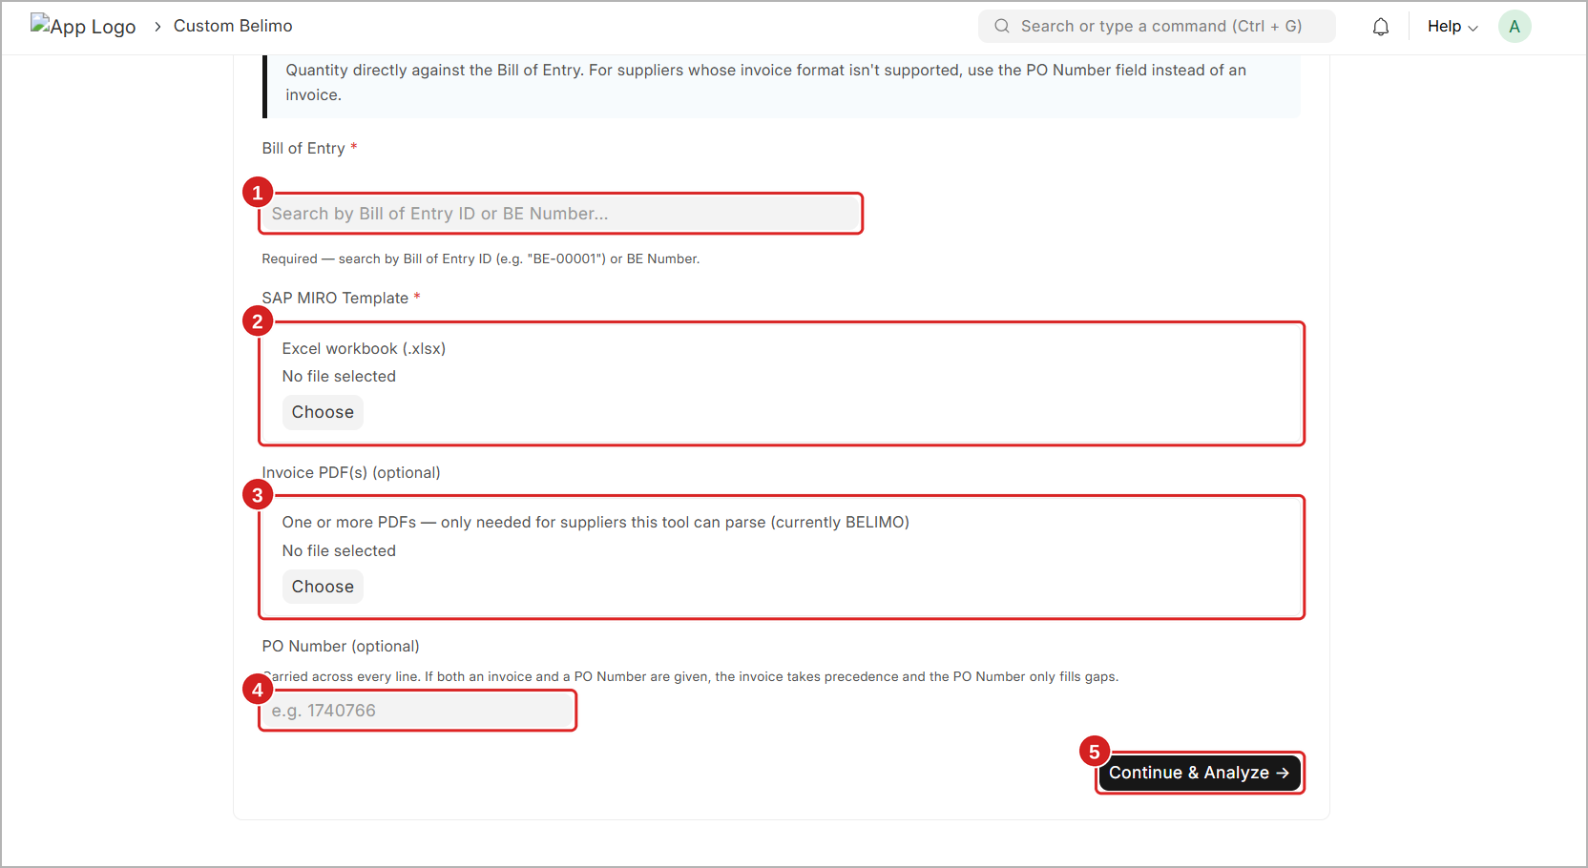
Figure 8: Step 1 – All fields before filling
1 Bill of Entry * – the BOE of this shipment. Required.
2 SAP MIRO Template * – your Excel template. Required.
3 Invoice PDF(s) – the supplier invoice. Optional.
4 PO Number – one PO number for all lines. Optional.
5 Continue & Analyze → – checks everything and opens Step 2.

4.2 Select the Bill of Entry
- Click the Bill of Entry box.
- Type the BOE ID (for example BE-00015) or the BE number (for example 2666385) (marker 1).
- Click the correct BOE in the list (marker 2). The BOE ID now shows in the box.
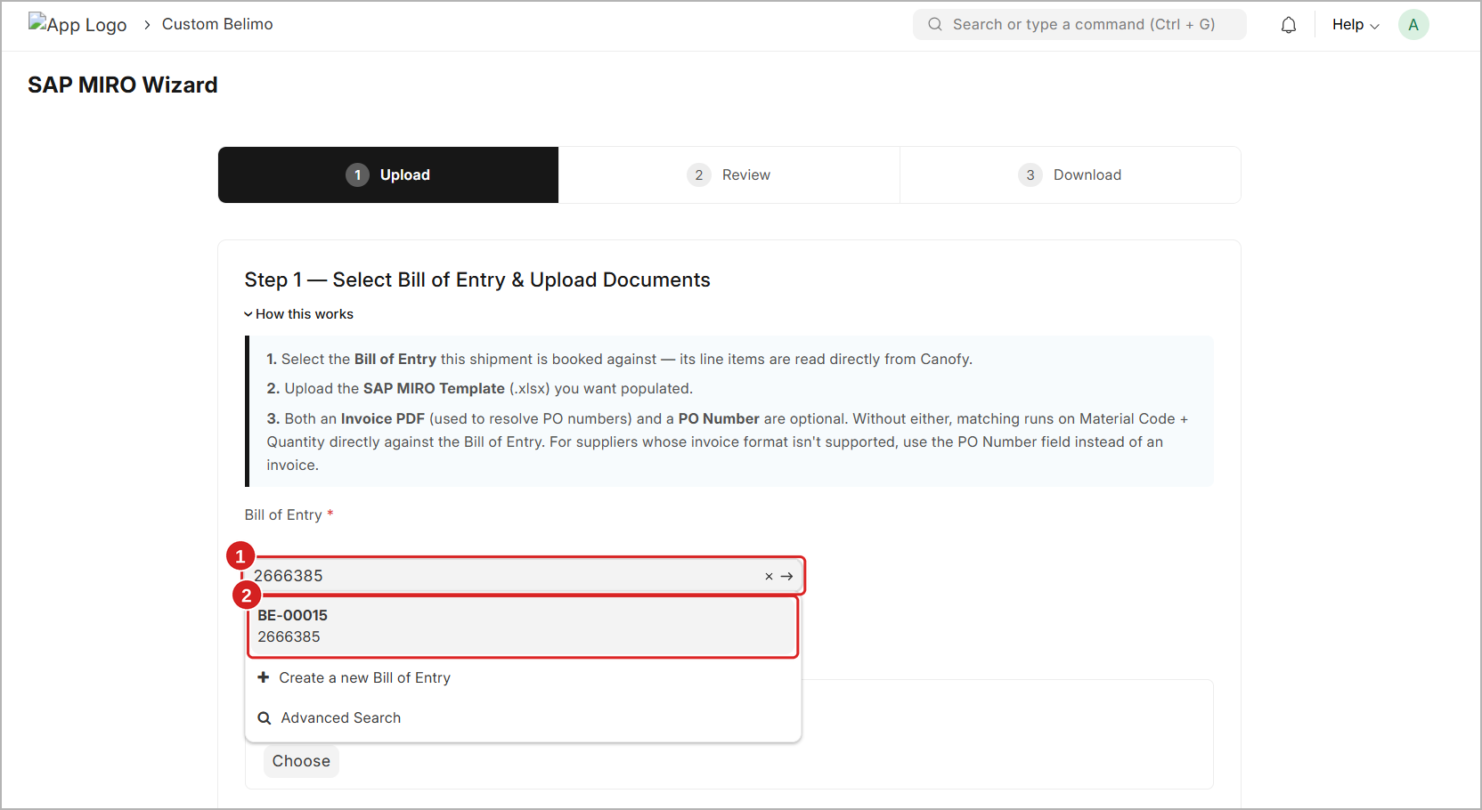
Figure 9: Step 1 – Searching the Bill of Entry by BE number
IMPORTANT
The wizard reads the items and duty values directly from this BOE in Canofy. If you select the wrong BOE, every value in the output will be wrong. Always check the BE number twice.

WARNING
Do not click Create a new Bill of Entry from this list. The BOE must be fully created and checked in Canofy before you use this wizard.

4.3 Prepare and Upload the SAP MIRO Template
The wizard accepts the template only in the standard format shown below. Do not add, remove, rename or move any column.
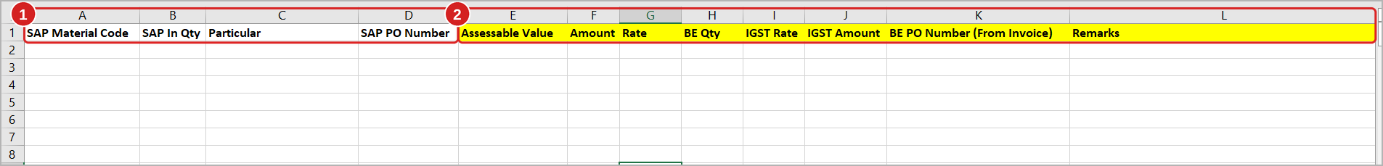
Figure 10: SAP MIRO Template – columns you fill and columns the wizard fills
1 Columns A to D – you fill these. SAP Material Code, SAP In Qty and Particular are mandatory. SAP PO Number is optional.
2 Yellow columns E to L – leave these empty. The wizard fills them. In the standard template the data is on the sheet named DataSheet.

Column | Who fills it | What it holds
A SAP Material Code | You | The material (item) code. Must match the BOE.
B SAP In Qty | You | The quantity received in SAP for this material.
C Particular | You | The duty type of this line (IN Basic customs, Social Welfare Surcharge / CustomsEducationCESS, Customs Sec H CESS).
D SAP PO Number | You (optional) | The PO number of this material in SAP.
E Assessable Value | Wizard | Assessable value of the material, from the BOE.
F Amount | Wizard | Duty amount for this particular.
G Rate | Wizard | Duty rate for this particular (for example 0.1 = 10%).
H BE Qty | Wizard | Quantity of this material in the BOE.
I IGST Rate | Wizard | IGST rate (for example 0.18 = 18%).
J IGST Amount | Wizard | IGST amount for this material.
K BE PO Number (From Invoice) | Wizard | PO number found for this material in the invoice or the PO Number field.
L Remarks | Wizard | Result of matching for this line, for example Matched.

NOTE
Each material normally has three lines in the template – one line for each Particular. Keep all three lines with the same material code and the same quantity.

To upload the template:
- In the SAP MIRO Template section, click Choose.
- Select your template file from your computer.
- Check that the file name now shows below Excel workbook (marker 2 in Figure 11).

4.4 Upload the Invoice PDF (Optional)
The invoice is used to find the correct PO number for each material. This is useful when one shipment has more than one PO (for example PO 1766754 and PO 1767371 in the same invoice).
- In the Invoice PDF(s) section, click Choose.
- Select the invoice PDF. You can select one or more PDFs if the shipment has more than one invoice.
- Check that the file name shows below the box (marker 3 in Figure 11).
NOTE
At present the wizard can read invoices from BELIMO only. For other suppliers, do not upload the invoice – use the PO Number field instead.

4.5 Enter the PO Number (Optional)
Type one PO number (for example 1740766) if all materials in the shipment belong to the same PO. This number is used for every line.
What you give | How the wizard finds the PO
Invoice PDF only | PO number is taken from the invoice for each material.
PO Number only | The same PO number is used for every line.
Both | The invoice is used first. The PO Number only fills lines that the invoice does not cover.
Neither | Matching is done only on Material Code + Quantity against the BOE.

4.6 Continue and Analyze
Check all fields once more, then click Continue & Analyze →.
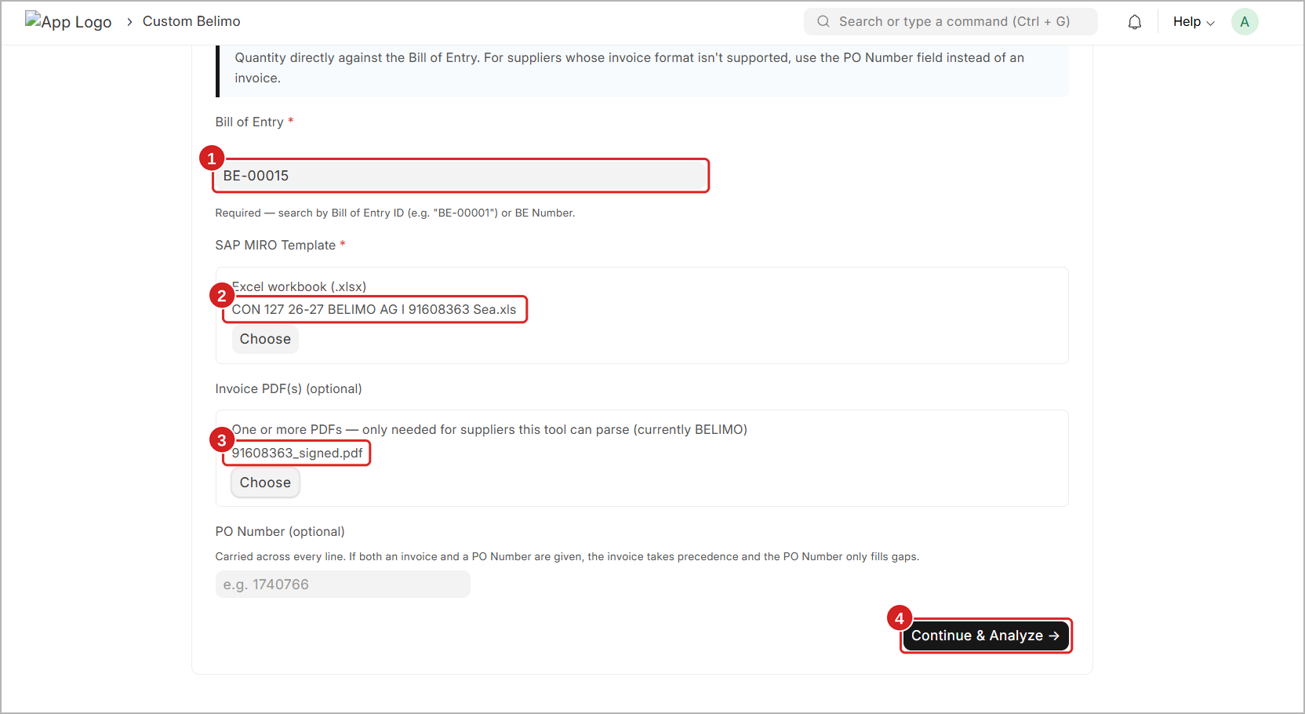
Figure 11: Step 1 – BOE selected, template and invoice uploaded, ready to continue
1 Bill of Entry – the selected BOE (BE-00015).
2 SAP MIRO Template – the uploaded template file.
3 Invoice PDF – the uploaded invoice file.
4 Continue & Analyze → – click to start the matching.

TIP
The wizard may take a few seconds to read a large invoice (for example a 10-page invoice with 81 lines). Please wait and do not click the button again.

5. Step 2 — Review
GOAL OF THIS STEP  Check the matching result for every material | BUTTON TO MOVE ON  Generate SAP MIRO Output

The wizard has now compared your template with the BOE (and the invoice, if uploaded). No output file is created yet. Check the result carefully before you go on.

5.1 Read the Summary
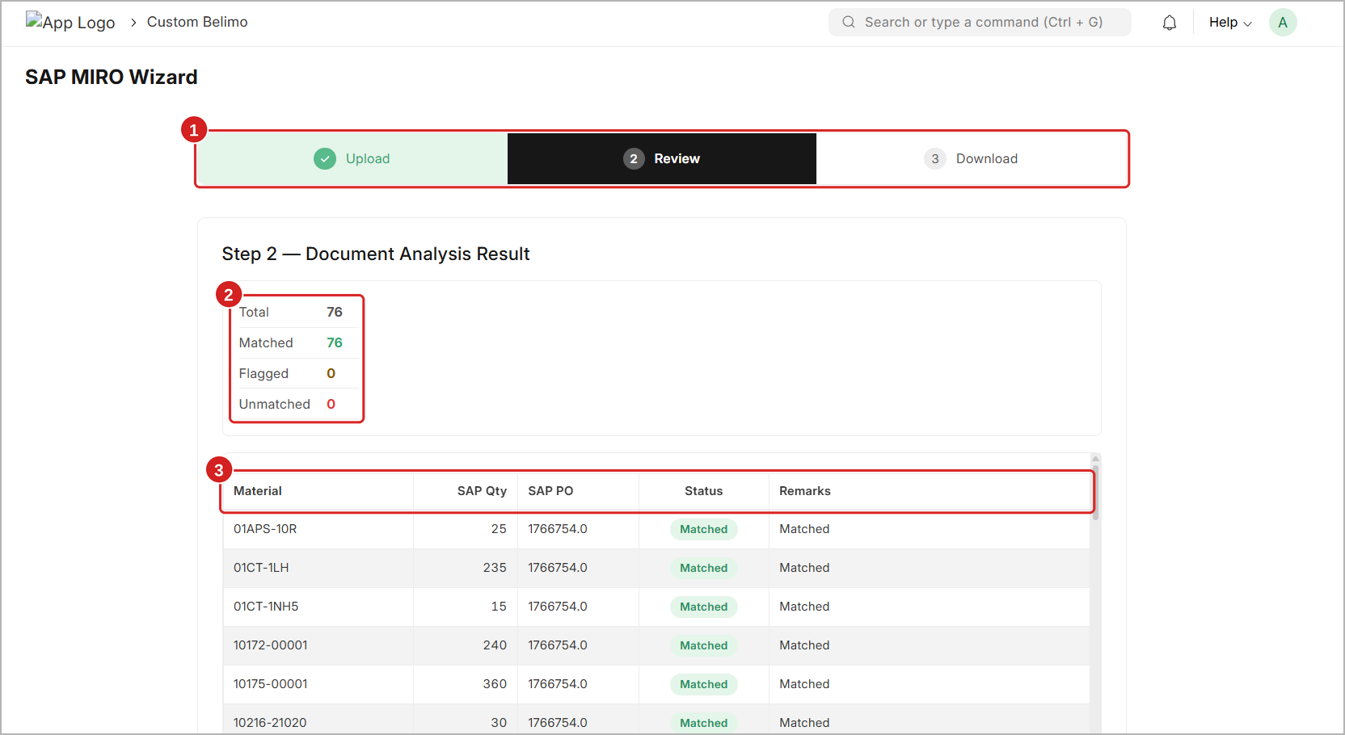
Figure 12: Step 2 – Document Analysis Result with summary and material list
1 Step bar – Upload is green with a tick. Review is now the current step.
2 Summary – total count of materials and how many are matched, flagged or unmatched.
3 Material list – one row for each material in your template.

Count | What it tells you | In this example
Total | How many materials were found in your template. | 76
Matched | Materials found in the BOE with the right quantity. Values will be filled (shown in green). | 76
Flagged | Materials found, but the wizard is not sure which BOE line to use. You must check them by hand (shown in orange). | 0
Unmatched | Materials not found in the BOE at all (shown in red). | 0

TIP
The best result is when Matched = Total and Flagged = 0 and Unmatched = 0, like in this example.

5.2 Review the Material List
Scroll down inside the list to see all materials. The list has these columns:
Column | Meaning
Material | The SAP Material Code from your template.
SAP Qty | The SAP In Qty from your template.
SAP PO | The PO number found for this material.
Status | The result of matching (see 5.3).
Remarks | A short reason or note for the status.

5.3 Understand the Status
Status | What it means | What you should do
● Matched | Material and quantity were found in the BOE. | Nothing.
● Flagged | Material was found, but it needs a manual check (for example it is in the BOE more than once). | Note the material. After download, check it in the output (see Section 8).
● Unmatched | Material was not found in the BOE. | Check the material code in the template and in the BOE (see Section 8.4).

5.4 Generate the Output
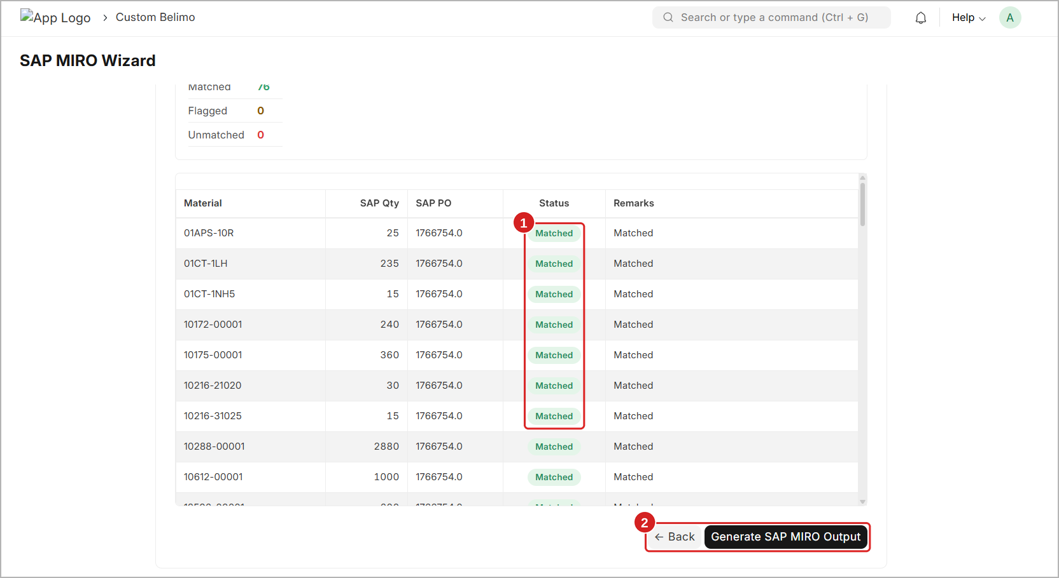
Figure 13: Step 2 – Status column and Generate SAP MIRO Output button
1 Status – check that the materials show Matched.
2 ← Back and Generate SAP MIRO Output – Back returns to Step 1. Generate creates the output workbook.

- Check the summary and the list.
- If something looks wrong (for example the wrong BOE), click ← Back and correct it in Step 1.
- If everything is fine, click Generate SAP MIRO Output. The wizard opens Step 3.
NOTE
You can generate the output even if some materials are Flagged or Unmatched. These lines will not be filled automatically. You must fill them by hand in the output file.

6. Step 3 — Download
GOAL OF THIS STEP  Download the filled SAP MIRO workbook | BUTTON TO MOVE ON  Download Workbook

The output workbook is ready. This page shows the file name and the final count of every type of match.

6.1 Read the Result
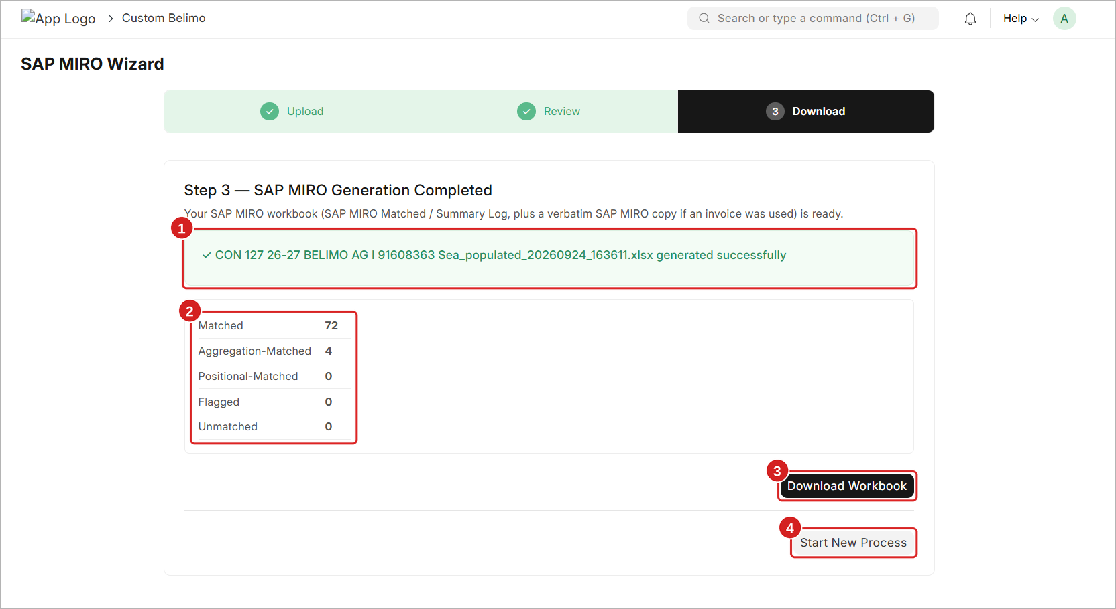
Figure 14: Step 3 – SAP MIRO Generation Completed
1 Success message – the name of the new file. It is your template name + _populated_ + date and time, for example …Sea_populated_20260924_163611.xlsx.
2 Result counts – the final count of each match type.
3 Download Workbook – downloads the file to your computer.
4 Start New Process – goes back to Step 1 for a new shipment.

Count | What it means | In this example
Matched | One material line in the template = one line in the BOE. Filled directly. | 72
Aggregation-Matched | The material is in the BOE on more than one line. The wizard added the BOE lines together to match your quantity. Please check. | 4
Positional-Matched | The same material and quantity are in the BOE more than once. The wizard matched them by the line order. Please check. | 0
Flagged | Needs a manual check. Not filled automatically. | 0
Unmatched | Not found in the BOE. Not filled. | 0

NOTE
In Step 2 the count showed 76 Matched. In Step 3 the same 76 are split into 72 Matched + 4 Aggregation-Matched. This is normal.

6.2 Download the Workbook
- Click Download Workbook.
- Two messages appear at the bottom-right: Generating SAP MIRO workbook… and then SAP MIRO workbook generated successfully (marker 1).
- The file is saved in the Downloads folder of your computer.
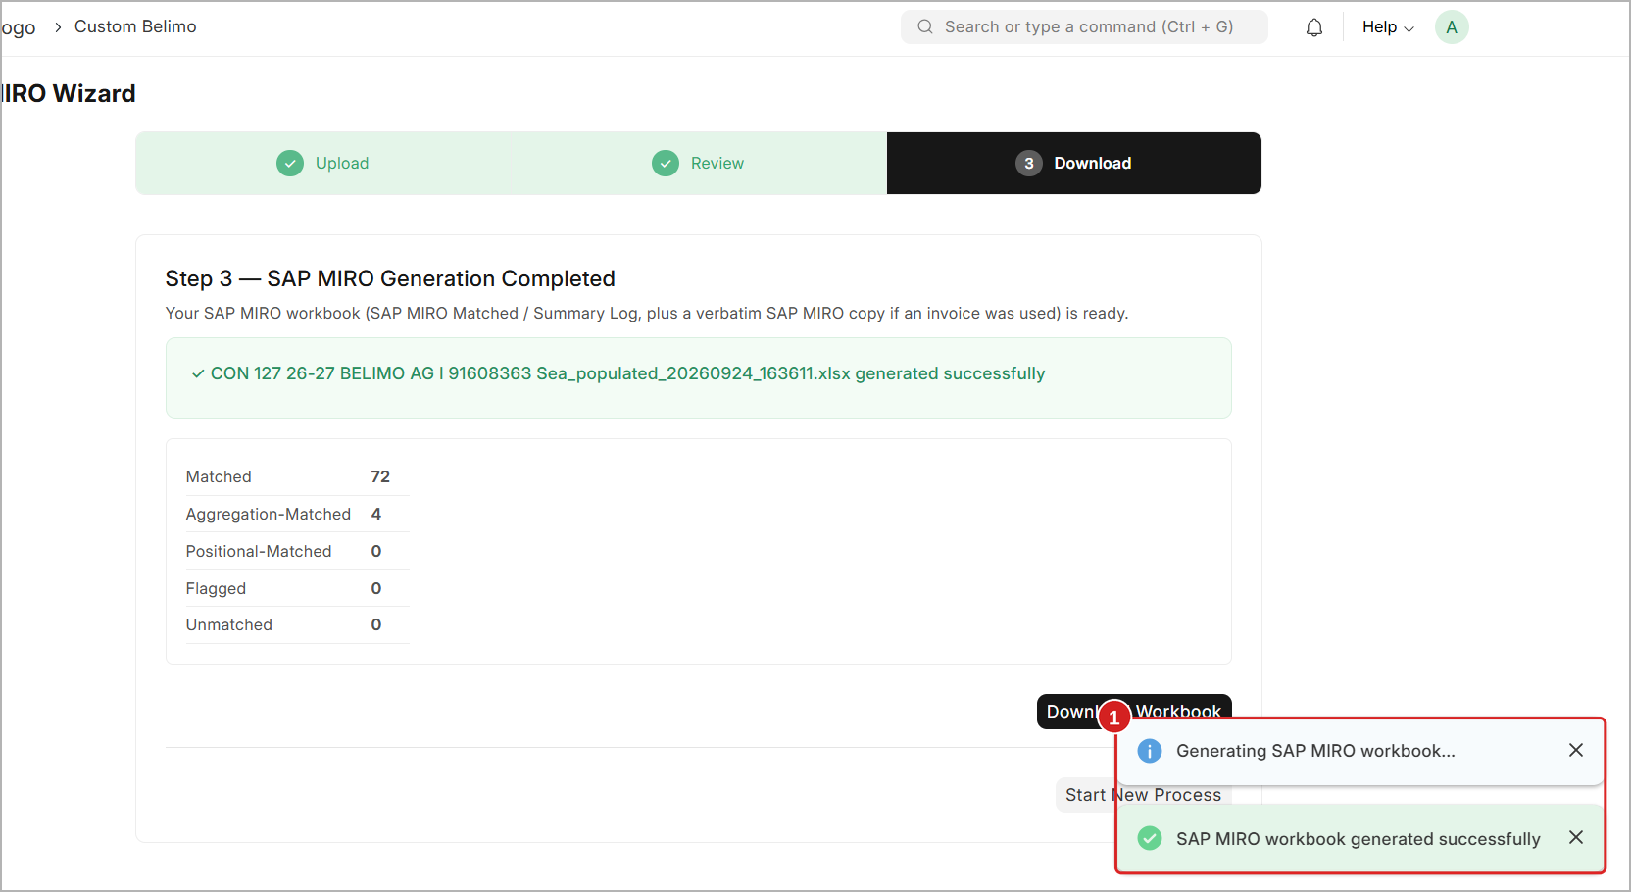
Figure 15: Step 3 – Messages shown while the workbook is downloaded

6.3 Start a New Process
To work on another shipment, click Start New Process. The wizard goes back to Step 1 with empty fields.
IMPORTANT
Download the workbook before you click Start New Process. The screen is cleared when a new process starts.

7. Understanding the Output Workbook
Open the downloaded file in Excel. It has these sheets:
Sheet | What it holds
SAP MIRO Matched | Your template with all duty columns filled. This is the sheet you use for SAP MIRO.
Summary Log | A report of the run – which materials matched, which need a check, and the total duty.
Invoice Extracted Data | Every line read from the invoice PDF. Shown only when an invoice was uploaded.

7.1 SAP MIRO Matched Sheet
This sheet has the same 12 columns as your template. For each material, the wizard fills the values from the BOE. The example below shows material 01APS-10R (25 pieces).
Material | Qty | Particular | SAP PO | Assess. Value | Amount | Rate | BE Qty | IGST Rate | IGST Amt | BE PO | Remarks
01APS-10R | 25 | IN Basic customs | 1766754 | 15378.19 | 1537.8 | 0.1 | 25 | 0.18 | 3072.6 | 1766754 | Matched
01APS-10R | 25 | CustomsEducationCESS | 1766754 |  | 153.8 | 0.1
01APS-10R | 25 | Customs Sec H CESS | 1766754 |  | 0 | 0

NOTE
Assessable Value, BE Qty, IGST Rate, IGST Amount, BE PO Number and Remarks are filled only on the IN Basic customs line of each material. Amount and Rate are filled on every line.

Always read the Remarks column (column L). If it shows anything other than Matched, check that material (see Section 8).

7.2 Summary Log Sheet
The Summary Log is a short report of the run. Read it from top to bottom:
Part | What it shows
Header | Run date and time, template file name, Bill of Entry, BE number and how PO matching was done (for example Material + PO Number).
A — Matched Items | Every matched material with SAP Qty, SAP PO, BE CQTY, BE PO, number of rows, Status and Notes. Aggregation and positional matches are also listed here.
B — Flagged Items | Materials that need manual work, with the Flag Type and the Action Required.
C — Unmatched Items | Materials not found in the BOE, with the Reason.
TOTALS | Final counts and the Total Duty Populated in INR.

TIP
Use the TOTALS line to cross-check the total duty with the duty in the BOE before posting in SAP.

7.3 Invoice Extracted Data Sheet
This sheet shows every line the wizard read from the invoice PDF: Invoice Number, Position, Material, Description, Quantity, UOM, Origin, Unit Price, Net Price, HSN Code and PO Number. Use it to check that the invoice was read correctly – for example, that the quantity and PO of each material are the same as on the paper invoice.

8. Checking and Fixing Remarks
The wizard fills most lines by itself. Lines that need your attention are shown in the Remarks column of the SAP MIRO Matched sheet and in parts B and C of the Summary Log.
IMPORTANT
The golden rule: never guess a value. Always compare the template with the BOE in Canofy for that material, then correct the output file or the data at the source.

8.1 Aggregation Detected
Remark: AGGREGATION DETECTED – aggregated values populated, check manually. BE CQTYs: 30, 20
Why it happens: the material is in the BOE on two or more lines (for example CM24-L with 30 + 20 pieces). Your template has one line with the total (50). The wizard added the BOE lines together and filled the total values. The values are usually correct.
What to do:
- Open the BOE in Canofy (search it with Ctrl + G).
- Find all lines of that material and add their quantities.
- Check that the total is the same as SAP In Qty in the template.
- If it is the same, no change is needed. If not, see Section 8.3.

8.2 Duplicate – Unresolved (Flagged)
Remark: DUPLICATE – UNRESOLVED – no single CQTY match. Review BE data and populate manually. BE CQTYs: 24, 1, 125, 25
Why it happens: the material is in the BOE many times with different quantities (for example 22DTH-13M), and no single line or clear total matches your quantity. The wizard does not fill this line.
What to do:
- Look at part B — Flagged Items of the Summary Log. Note the material and the BE CQTYs.
- Open the BOE in Canofy and find all lines of that material.
- Decide which BOE line(s) belong to this template line (use the PO number and the invoice to help).
- Fill the values of that line by hand in the SAP MIRO Matched sheet.

8.3 Quantity Mismatch
Why it happens: the material is found, but the SAP In Qty in the template is not the same as the quantity (CQTY) in the BOE.
What to do:
- Check the quantity of that material in the template.
- Check the quantity of the same material in the BOE in Canofy.
- Find which one is wrong. Correct the template, or ask the team that owns the BOE to correct it.
- Run the wizard again with the corrected data.

8.4 Product Not Found (Unmatched)
Why it happens: the material code in the template is not in the BOE. Very often there is a small difference, like an extra space at the end, a missing dash or a wrong letter.
What to do:
- Look at part C — Unmatched Items of the Summary Log.
- Compare the material code in the template with the code in the BOE, letter by letter.
- Remove extra spaces or correct the spelling in the template.
- If the Part Code in the BOE is wrong or has a space, ask the Logistics team to correct it in Canofy (see Section 2.4). If the material is really missing in the BOE, check the BOE with your team.
- Run the wizard again.
WARNING
Do not type duty values by hand for an Unmatched material unless you have checked them in the BOE. Wrong values in SAP MIRO are hard to reverse.

9. Troubleshooting
Use this table if something does not work as expected.
Problem | Likely reason | What to do
BOE does not appear in the search list | The BOE is not created yet, or the number is typed wrong. | Check the BE number. Make sure the BOE exists in Canofy.
Continue & Analyze does nothing | A required field (Bill of Entry or SAP MIRO Template) is empty. | Fill both required fields (*).
Template is not accepted | The file is not in the standard template format, or columns were changed. | Use the standard template. Do not rename or move columns.
All SAP PO values are empty | No invoice and no PO Number were given. | Upload the invoice PDF, or type the PO Number.
Wrong PO number on lines | The PO Number field was used for a shipment with more than one PO. | Upload the invoice PDF instead, so each material gets its own PO.
Invoice is not read | The invoice is not from a supported supplier (only BELIMO at present). | Remove the PDF and use the PO Number field.
Many materials are Unmatched | The wrong BOE was selected. | Click ← Back and select the correct BOE.
A material is Unmatched, but it is in the BOE | The Part Code in the BOE has a space, a typing error or is empty. | Ask the Logistics team to correct the Part Code (Section 2.4), then run the wizard again.
Duty values look wrong | The BOE in Canofy has wrong values. | Correct the BOE in Canofy, then run the wizard again.
File did not download | The browser blocked the download. | Allow downloads for this site and click Download Workbook again.

NEED MORE HELP?
Still stuck? Contact your system administrator or support team. Share the BOE number, the template file, the downloaded workbook (Summary Log) and a screenshot of the screen.

10. Best Practices
RECOMMENDATIONS
✓ Run the wizard only after the Logistics team has completed the Part Code pre-check (Section 2.1).
✓ Always check the BE number twice before you continue.
✓ Always use the standard SAP MIRO Template. Never add, remove or rename columns.
✓ Keep material codes exactly as in the BOE – no extra spaces.
✓ Upload the invoice PDF for BELIMO shipments, especially when there is more than one PO.
✓ Read the Summary Log after every run, and check every line that is not Matched.
✓ Cross-check the Total Duty Populated with the BOE before posting in SAP.
✓ Download the workbook before you click Start New Process.

Quick Reference
Step | You do | Click
0 Pre-Check | Logistics team checks and corrects the Part Code of every BOE line item in Canofy | Update / Save (Ctrl + S)
1 Upload | Select the BOE, upload the template, invoice PDF (optional) and PO Number (optional) | Continue & Analyze →
2 Review | Check the summary and the status of each material | Generate SAP MIRO Output
3 Download | Download the workbook and check the Remarks and Summary Log | Download Workbook

