USER MANUAL
Bulk GRV Import Wizard
A simple, step-by-step guide to creating many CGRNs at once from one Bulk GRV Excel file

Document Title | Bulk GRV Import Wizard – User Manual
Application | Canofy
Workspace | Custom Mil Power

Table of Contents
1. Introduction 3
1.1 Purpose of This Manual 3
1.2 Key Words Used in This Manual 3
1.3 How the Wizard Works 3
2. Before You Begin 4
3. Opening the Wizard 5
4. Step 1 — Upload 6
4.1 Choose and Upload the File 6
4.2 Start Parsing 7
5. Step 2 — Parse & Group Preview 9
5.1 Read the Summary 9
5.2 Choose the Insurance Policy 10
5.3 Selection Buttons 10
5.4 Review the Document List 10
5.5 Understand the Status 11
5.6 Select Documents and Start Processing 12
6. Step 3 — Background Processing 13
7. Step 4 — Results 14
7.1 Buttons on This Page 14
7.2 Read the Results Table 14
7.3 What Does "Duplicate" Mean? 15
7.4 If a Document Shows Error 15
8. Step 5 — Done 16
8.1 What to Do 16
9. Fixing Errors 17
9.1 Find the Reason – Download the Error Report 17
9.2 Lot Number Not Found (Pending — Lot Issues) 17
9.3 BOE Not Found (Blocked — BOE Not Found) 17
9.4 Unassigned Lines 18
9.5 Error in Step 4 18
10. Troubleshooting 19
11. Best Practices 20
Quick Reference 20

1. Introduction
The Bulk GRV Import Wizard helps you create many CGRNs in one go. You upload one Excel file exported from Priority ERP. This file can contain many GRV Documents. The wizard reads the file, checks every line against the data in Canofy, and creates one CGRN for each Document you select.
In short: one Excel file in → many CGRNs out. You do not need to create each CGRN by hand.

1.1 Purpose of This Manual
This manual explains every screen of the wizard, what each button does, what each status means, and how to fix problems when a Document cannot be processed.

1.2 Key Words Used in This Manual
Word | Meaning (in simple words)
GRV | Goods Receipt Voucher. The receipt record exported from Priority ERP.
Document | One GRV number in the Excel file (for example CR26001105). One Document can have one or many item lines.
CGRN | Customer Goods Receipt Note. The record the wizard creates in Canofy. One CGRN is created for each Document (for example CGRN-2026-000060).
BOE | Bill of Entry. Every Document must be linked to a BOE that already exists in Canofy.
Lot Number | The lot record in Canofy. Each item line in the Excel file must match a Lot Number in Canofy exactly.
Product Master | The item (product) record in Canofy. It holds the item details used by the BOE and its lot lines.
Insurance Policy | The policy you choose in Step 2. It is added to every CGRN created in that run.
Bulk GRV File | The consolidated Excel (.xlsx) export from Priority ERP, with its data on a sheet named DataSheet.
Error Report | A file you can download in Step 2. It lists every problem line and the reason.
Final Report | A file you can download in Step 4. It lists the result of every Document in the run.

1.3 How the Wizard Works
The wizard has five steps. The bar at the top of the page always shows where you are: the current step is shown in black, and finished steps show a tick mark.
STEP 1  Upload | STEP 2  Parse & Group Preview | STEP 3  Background Processing | STEP 4  Results | STEP 5  Done
Upload the Bulk GRV Excel file | Check Documents, choose Insurance Policy, select | Wizard creates the CGRNs one by one | See what was created, retry errors | Open your new CGRNs

2. Before You Begin
Please check these points before you start. This saves time and avoids errors later.
CHECKLIST
✓ You have the original Bulk GRV Excel file (.xlsx) exported from Priority ERP.
✓ The data is on the sheet named DataSheet. Do not rename this sheet.
✓ You have not added, removed, renamed or moved any columns. The wizard reads only one fixed layout.
✓ The Bills of Entry (BOE) for these Documents already exist in Canofy.
✓ The Lot Numbers for these items are correct in Canofy (in the BOE and its Product Master).
✓ You know which Insurance Policy to use for this import.
✓ You have permission to create CGRNs in Canofy.

NOTE
This wizard uses a fixed column layout for one known export format. Unlike the single GRV to CGRN Import Wizard, there is no Mapping Profile to choose.

3. Opening the Wizard
GOAL OF THIS STEP  Open the Bulk GRV Import Wizard | BUTTON TO MOVE ON  Bulk GRV Import Wizard link

The wizard is in the Custom Mil Power workspace.
- Log in to Canofy.
- In the left menu, under PUBLIC, click Custom Mil Power (marker 1).
- In the Quick Access section, click Bulk GRV Import Wizard (marker 2).
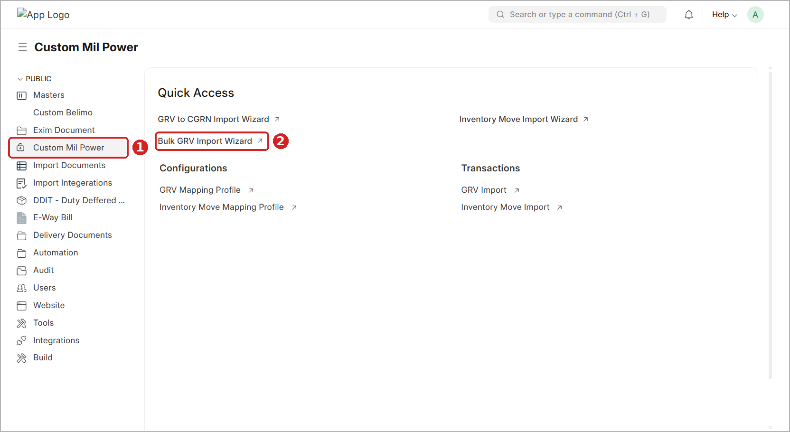
Figure 1: Custom Mil Power workspace – Bulk GRV Import Wizard link in Quick Access
TIP
Do not confuse it with GRV to CGRN Import Wizard (one file, one CGRN) or Inventory Move Import Wizard. For many Documents in one file, always use Bulk GRV Import Wizard.

4. Step 1 — Upload
GOAL OF THIS STEP  Upload your Bulk GRV Excel file | BUTTON TO MOVE ON  Upload & Parse →

The wizard opens on Step 1. The grey box at the top reminds you which file to use. The Upload & Parse button stays grey (disabled) until a file is uploaded.
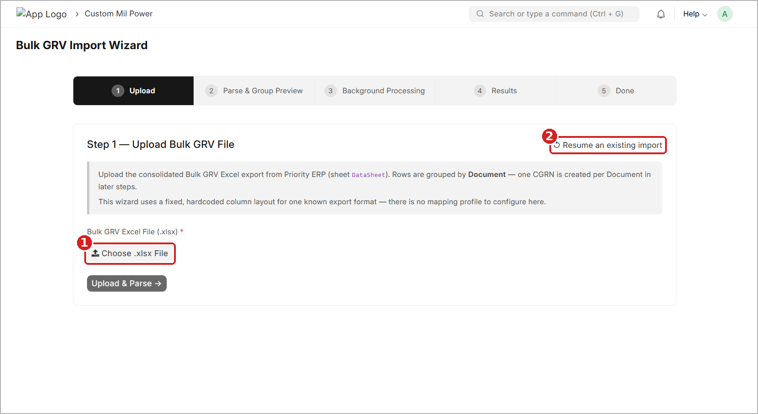
Figure 2: Step 1 – Upload screen before choosing a file
1 Choose .xlsx File – opens the Upload window.
2 Resume an existing import – continues an import you left half-done earlier (see the tip below).

4.1 Choose and Upload the File
- Click Choose .xlsx File. The Upload window opens.
- Click My Device and select your Bulk GRV Excel file from your computer. You can also drag and drop the file into the window.
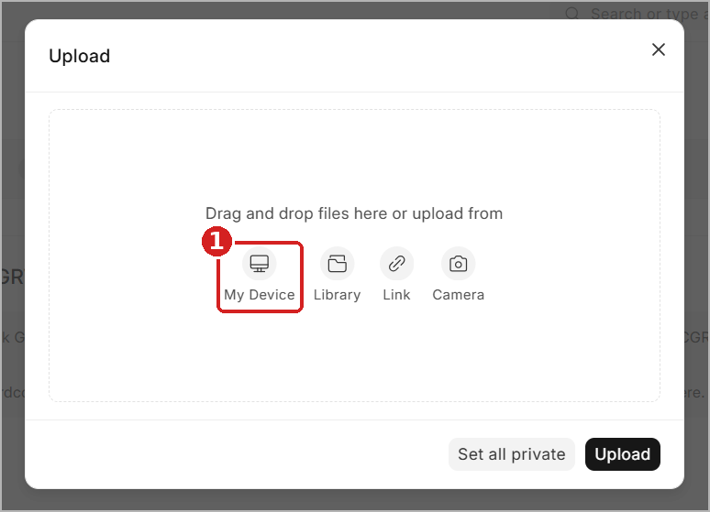
Figure 3: Upload window – select the file from My Device
- Check the file name and size. Keep the Private box ticked (this is the default and keeps the file visible only to authorised users).
- Click Upload.
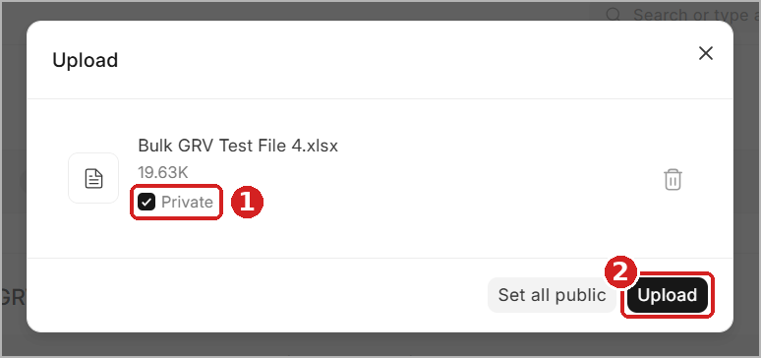
Figure 4: Upload window – file selected, Private ticked, ready to upload
NOTE
Do not click Set all public. The Bulk GRV file contains business data and should stay private.

4.2 Start Parsing
- Wait for the green tick. The file name appears below the button with the word uploaded (marker 1).
- Click Upload & Parse → (marker 2). The wizard reads the file and opens Step 2.
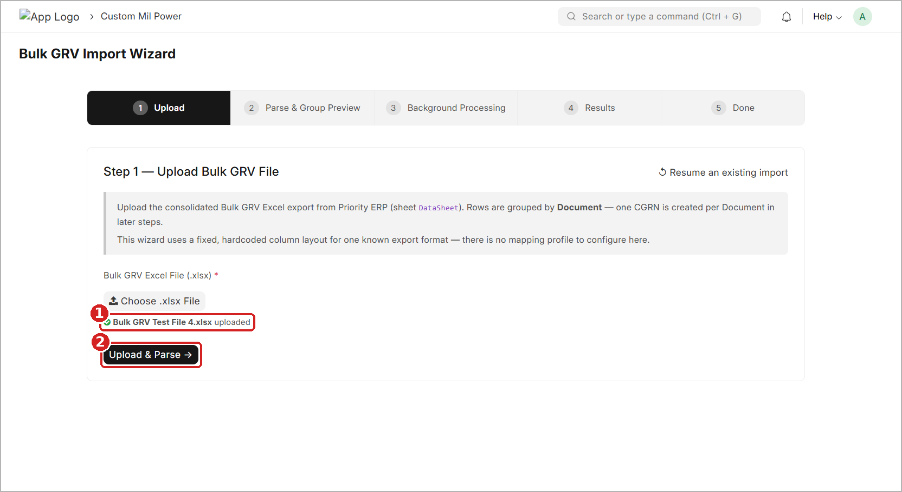
Figure 5: Step 1 – File uploaded (green tick) and Upload & Parse button active
NOTE
Rows in the file are grouped by Document. One CGRN will be created for each Document in the later steps.

TIP
Did you leave an import half-done earlier? Click Resume an existing import (top-right of Step 1) to continue it instead of uploading the same file again.

5. Step 2 — Parse & Group Preview
GOAL OF THIS STEP  Check the Documents, choose Insurance Policy, select what to process | BUTTON TO MOVE ON  Next: Start Processing →

The wizard has now read your file. This is the most important step. Here you check the results, choose the Insurance Policy, and select which Documents should become CGRNs. Nothing is created in Canofy yet.

5.1 Read the Summary
At the top you see five number cards (marker 1) and one summary line below them.
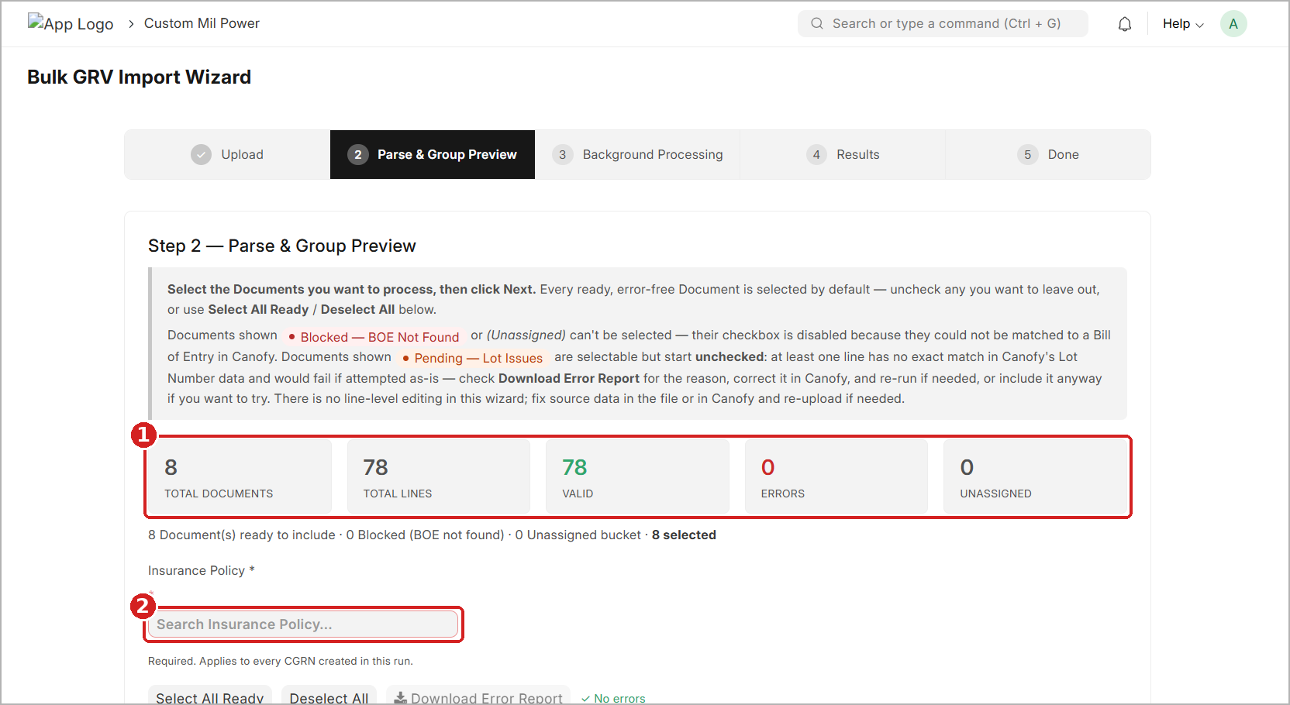
Figure 6: Step 2 – Summary cards and empty Insurance Policy field
Card | What it tells you | In this example
Total Documents | How many Documents (GRV numbers) were found in the file. One CGRN per Document. | 8
Total Lines | How many item lines were found in the whole file. | 78
Valid | Lines that passed every check (shown in green). | 78
Errors | Lines with a problem – usually no exact Lot Number match in Canofy (shown in red). | 0
Unassigned | Lines that could not be linked to any Bill of Entry. | 0

The summary line shows how many Documents are ready, blocked or unassigned, and how many you have selected. In this example: 8 Document(s) ready to include · 0 Blocked (BOE not found) · 0 Unassigned bucket · 8 selected.
TIP
The best result is when Valid = Total Lines and Errors = 0, like in this example. If Errors is more than 0, see Section 9 – Fixing Errors before you continue.

5.2 Choose the Insurance Policy
- Click the Insurance Policy box (marker 2 in Figure 6). It has a red border while it is empty.
- Type a few characters of the policy number and choose the correct policy from the list.
- Check that the selected policy number now shows in the box (marker 1 in Figure 7).
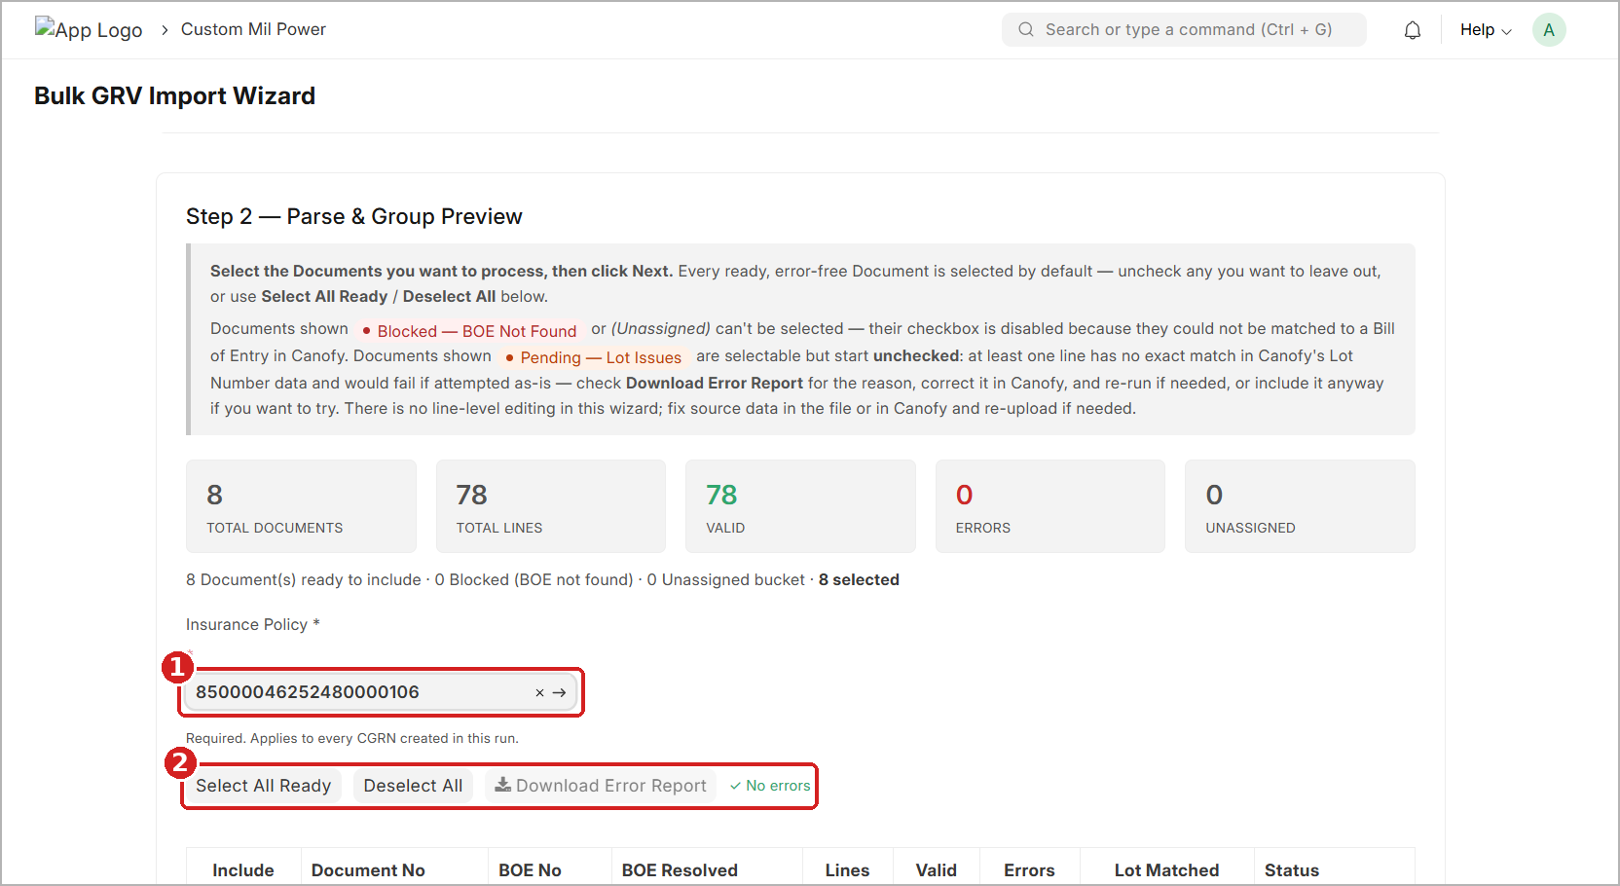
Figure 7: Step 2 – Insurance Policy selected, selection buttons and error status
IMPORTANT
Insurance Policy is required. The same policy is applied to every CGRN created in this run. If different Documents need different policies, import them in separate runs.

5.3 Selection Buttons
The buttons below the Insurance Policy (marker 2 in Figure 7) help you select Documents quickly.
Button | What it does
Select All Ready | Ticks every Document that is ready and has no errors.
Deselect All | Removes all ticks.
Download Error Report | Downloads a file that lists each problem line and the reason. It is greyed out when there are no errors, and the text ✓ No errors is shown next to it.

5.4 Review the Document List
Scroll down to see one row for each Document. Use this table to decide what to include.
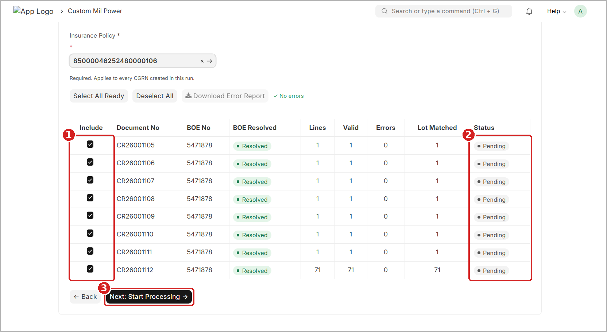
Figure 8: Step 2 – Document list with Include tick boxes, Status and Next button
1 Include – tick boxes. All ready Documents are ticked by default.
2 Status – shows whether each Document is ready.
3 Next: Start Processing → – starts creating the CGRNs.

Column | Meaning
Include | Tick box. Ticked = this Document will be processed.
Document No | The GRV Document number from the file (for example CR26001105).
BOE No | The Bill of Entry number from the file.
BOE Resolved | Green Resolved = the BOE was found in Canofy.
Lines | Number of item lines in this Document.
Valid / Errors | How many lines are OK / how many have a problem.
Lot Matched | How many lines matched a Lot Number in Canofy. It should be equal to Lines.
Status | Whether the Document is ready. See Section 5.5.

5.5 Understand the Status
Status | What it means | What you should do
● Pending | All lines are OK. Ready to process. Ticked automatically. | Nothing. Keep it ticked.
● Pending — Lot Issues | At least one line has no exact Lot Number match in Canofy. You can tick it, but it starts unticked. | Download the Error Report and fix the Lot Number in Canofy. Then upload the Excel again. See Section 9.2.
● Blocked — BOE Not Found | The Bill of Entry was not found in Canofy. The tick box is disabled. | Check the BOE in Canofy, fix it, then upload the Excel again. See Section 9.3.
(Unassigned) | Lines could not be linked to any Bill of Entry. The tick box is disabled. | Check the BOE details of these lines. See Section 9.4.

IMPORTANT
One bad line affects the whole Document. For example, if CR26001112 has 71 lines and 2 of them have Lot Number errors, the whole Document is marked Pending — Lot Issues. This is because one CGRN is created for the whole Document.

NOTE
You cannot edit lines inside this wizard. To fix a problem, correct the data in Canofy, then upload the Excel file again.

5.6 Select Documents and Start Processing
- Make sure the Insurance Policy is selected.
- Tick the Documents you want. By default, all ready Documents are already ticked.
- If there are errors, click Download Error Report and fix them first (see Section 9).
- Check the selected count in the summary line.
- Scroll to the bottom and click Next: Start Processing →. To go back to Step 1, click ← Back.
WARNING
Only tick a Pending — Lot Issues Document if you are sure. It will most likely fail in Step 4. The better way is to fix the Lot Number in Canofy first and upload again.

6. Step 3 — Background Processing
GOAL OF THIS STEP  Let the wizard create the CGRNs | BUTTON TO MOVE ON  Moves to Step 4 by itself

The screen title changes to Creating CGRNs. The wizard now creates one CGRN in Canofy for each Document you selected, one at a time.
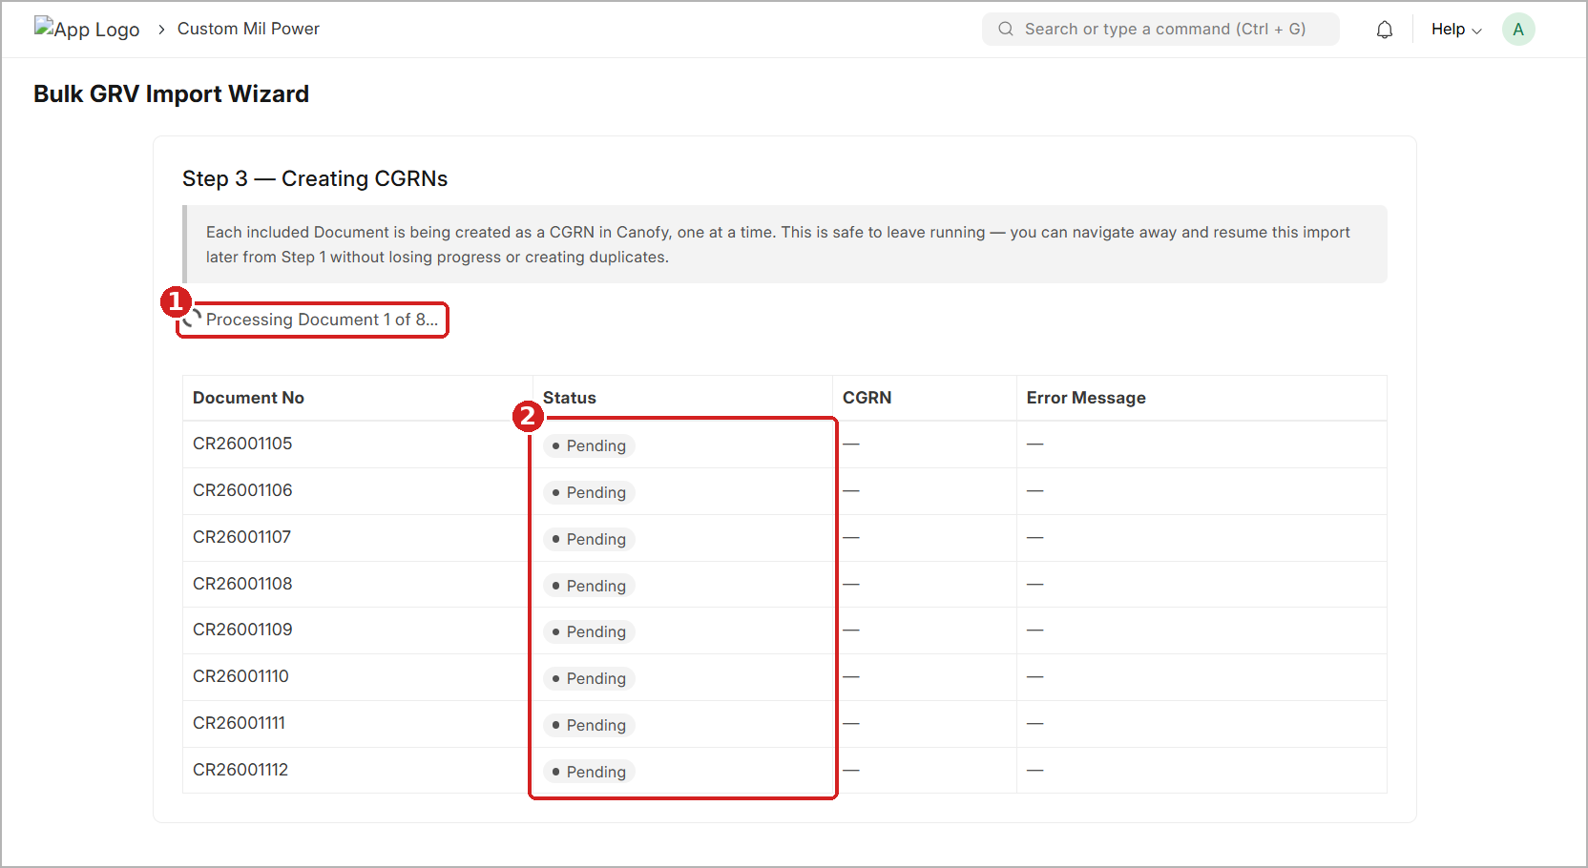
Figure 9: Step 3 – CGRNs being created, one Document at a time
1 Progress line – shows which Document is being processed, for example Processing Document 1 of 8…
2 Status – each Document starts as Pending and changes as it is processed. The CGRN column fills in when the CGRN is ready.

- Wait until processing is finished. A large file can take a few minutes.
- Do not upload the same file again while it is running.
- When processing ends, the wizard opens Step 4 — Results by itself.
TIP
It is safe to leave this running. You can move to another page and come back later. Open the wizard again and click Resume an existing import in Step 1. You will not lose progress and no duplicate CGRNs will be created.

7. Step 4 — Results
GOAL OF THIS STEP  Check which CGRNs were created and retry any errors | BUTTON TO MOVE ON  Next →

Processing is complete. This page shows the result for every Document you selected.
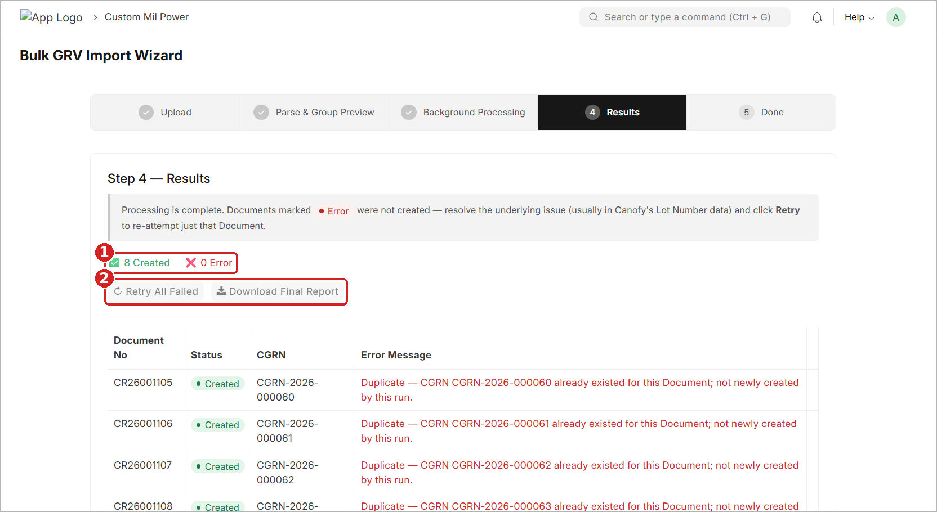
Figure 10: Step 4 – Result counts, Retry All Failed and Download Final Report
1 Result counts – how many Documents were Created (green) and how many have an Error (red).
2 Retry All Failed and Download Final Report buttons.

7.1 Buttons on This Page
Button | What it does
Retry All Failed | Runs the process again only for Documents with Error status. It is greyed out when there are 0 errors.
Retry (on a row) | Shown on a row with Error status. Runs the process again for just that one Document.
Download Final Report | Downloads a report of all results. Keep it for your records.
Next → | Goes to Step 5 — Done.

7.2 Read the Results Table
The table shows the Document No, its Status, the CGRN number and an Error Message if there is one.
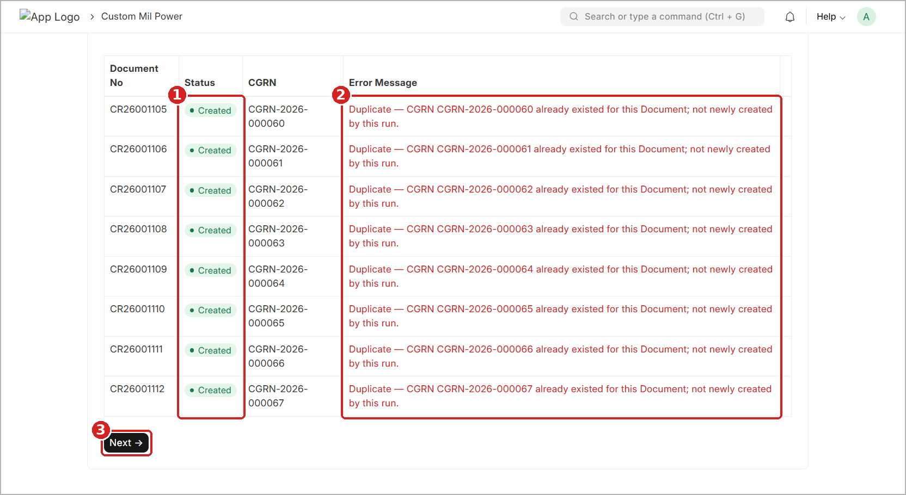
Figure 11: Step 4 – Results list with CGRN numbers and Duplicate messages
1 Status – Created means a CGRN exists for this Document.
2 Error Message – extra information about the result.
3 Next → – goes to Step 5.

7.3 What Does "Duplicate" Mean?
Sometimes the Status is Created but the Error Message (in red) says: Duplicate — CGRN CGRN-2026-000060 already existed for this Document; not newly created by this run.
This means a CGRN for that Document already existed – for example, from an earlier import of the same file. The wizard does not create a second copy. It simply shows you the existing CGRN number. You do not need to do anything.
TIP
If every row shows a Duplicate message (like in Figure 11), the same file was already imported before. Check your records before running the same file again.

7.4 If a Document Shows Error
- Read the Error Message for that Document.
- Fix the problem in Canofy. In most cases this is the Lot Number data (see Section 9.5).
- Come back and click Retry on that row, or Retry All Failed for all of them.
When you are happy with the results, scroll down and click Next →.

8. Step 5 — Done
GOAL OF THIS STEP  Open and check your new CGRNs | BUTTON TO MOVE ON  Start New Import

The green box confirms the result, for example 8 of 8 Documents created successfully. Below it you see every CGRN number with its Document number.
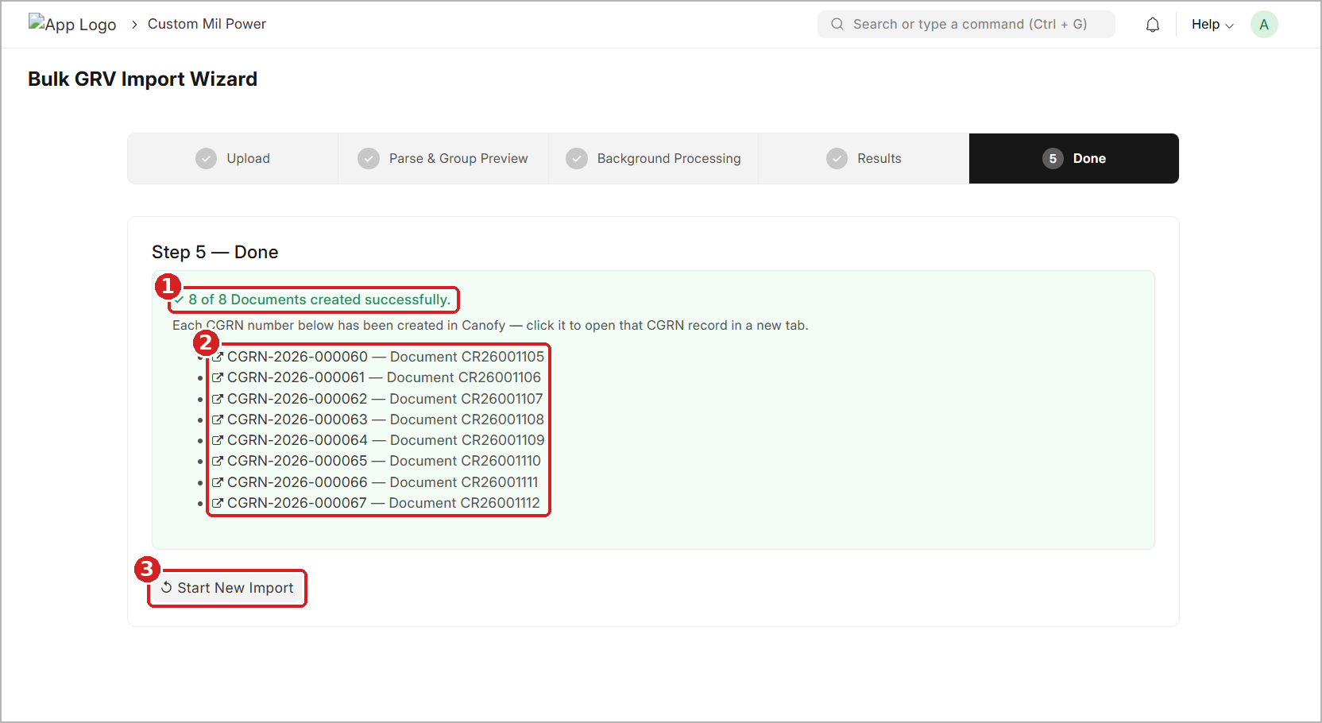
Figure 12: Step 5 – Done: list of CGRNs with links
1 Result message – how many Documents now have a CGRN.
2 CGRN list – click a CGRN number to open that record in a new browser tab.
3 Start New Import – goes back to Step 1 for a new file.

8.1 What to Do
- Click any CGRN number. It opens that CGRN in a new browser tab.
- Check the CGRN details in Canofy (items, quantities, Lot Numbers and Insurance Policy).
- To import another file, click Start New Import. The wizard goes back to Step 1.
NOTE
Documents that showed a Duplicate message in Step 4 are also listed here. The CGRN shown for them is the one that already existed.

9. Fixing Errors
Errors can appear at two points:
- In Step 2 (before anything is created) – a Document shows Pending — Lot Issues, Blocked — BOE Not Found or (Unassigned), and the Errors card is more than 0.
- In Step 4 (while creating the CGRN) – a Document shows Error status with an error message.
IMPORTANT
The golden rule: fix the data in Canofy, not in the wizard. The wizard cannot edit lines.
For errors found in Step 2, fix the data in Canofy and then upload the Excel file again. For errors found in Step 4, fix the data in Canofy and then click Retry.

9.1 Find the Reason – Download the Error Report
- In Step 2, click Download Error Report.
- Open the downloaded file.
- For each problem line, note the Document No, BOE No, item and Lot Number, and read the reason.

9.2 Lot Number Not Found (Pending — Lot Issues)
Why it happens: one or more item lines in the Excel file do not match a Lot Number in Canofy exactly. Even a small difference – an extra space, a missing leading zero, a different capital letter or a wrong character – is treated as “not found”.
How to fix it:
- Download the Error Report (Section 9.1) and note the BOE No, item and Lot Number of each failed line.
- Open Canofy in a new browser tab, so the wizard stays open.
- Search for the Bill of Entry (BOE) using the search bar (Ctrl + G) and open it.
- In the BOE, check the item lines and their Lot Numbers. Compare them with the Excel file line by line.
- Open the Product Master of the item that failed and check that its details (item code and lot information) are correct.
- Correct the wrong Lot Number or item data in Canofy and click Save.
- Go back to the wizard and upload the same Excel file again (Step 1 → Choose .xlsx File → Upload & Parse).
- In Step 2, check that the Document now shows Pending, Errors = 0 and Lot Matched = Lines.
WARNING
Do not change the Excel columns to “fix” a Lot Number. The Lot Number in Canofy must be corrected so that it matches the data exported from Priority ERP. If the Excel data itself is wrong, ask for a corrected export from Priority ERP.

9.3 BOE Not Found (Blocked — BOE Not Found)
Why it happens: the BOE No written in the Excel file does not exist in Canofy, or it is written differently.
- Note the BOE No of the blocked Document from the Document list.
- In Canofy, search for that BOE No (Ctrl + G).
- If the BOE does not exist, create or complete the Bill of Entry in Canofy first.
- If the BOE exists but the number is different, correct it so that it matches the Excel file exactly.
- Save, then upload the Excel file again in the wizard.

9.4 Unassigned Lines
Why it happens: some lines could not be linked to any Bill of Entry – for example, the BOE No is empty or not readable on those rows.
- Check the BOE No of these rows in the Excel file.
- Make sure the matching BOE exists in Canofy with the same number (see Section 9.3).
- If the BOE No is missing in the Excel file, get a corrected export from Priority ERP.
- Upload the Excel file again.

9.5 Error in Step 4
Why it happens: a problem was found while the CGRN was being created. In most cases it is the Lot Number data in Canofy.
- Read the Error Message on the row with Error status.
- Open Canofy in a new tab and fix the data – follow steps 3 to 6 of Section 9.2 (BOE → item lines → Product Master → Save).
- Come back to the wizard and click Retry on that row, or Retry All Failed.
- Check that the Status changes to Created and a CGRN number is shown.
TIP
You do not need to upload the file again for Step 4 errors – just fix the data and click Retry. If you closed the page, open the wizard and click Resume an existing import.

10. Troubleshooting
Use this table if something does not work as expected.
Problem | Likely reason | What to do
Upload & Parse button is grey | No file has been uploaded yet. | Click Choose .xlsx File, select the file and click Upload. Wait for the green tick.
File does not read correctly | Wrong file, sheet not named DataSheet, or columns were changed. | Use the original Priority ERP export. Do not change the column layout.
Pending — Lot Issues | One or more lines have no exact Lot Number match in Canofy. | Download the Error Report, fix the Lot Number in the BOE / Product Master in Canofy, upload again (Section 9.2).
Blocked — BOE Not Found | The BOE in the file is not in Canofy. | Create or correct the BOE in Canofy, upload again (Section 9.3).
(Unassigned) lines | Lines could not be linked to any BOE. | Check the BOE No in the file and in Canofy (Section 9.4).
Cannot move past Step 2 | Insurance Policy is empty, or no Document is ticked. | Select an Insurance Policy and tick at least one Document.
Download Error Report is grey | There are no errors in the file. | Nothing to do – ✓ No errors is shown.
Error in Step 4 | Data problem found while creating the CGRN. | Read the message, fix the data in Canofy, click Retry (Section 9.5).
"Duplicate" message | A CGRN already exists for that Document. | No action needed. The existing CGRN is shown.
Page closed during processing | Browser tab was closed or refreshed. | Open the wizard and click Resume an existing import.

NEED MORE HELP?
Still stuck? Contact your system administrator or support team. Share the Document No, the Error Report or Final Report, and a screenshot of the screen.

11. Best Practices
RECOMMENDATIONS
✓ Always use the original Excel file exported from Priority ERP.
✓ Never rename the DataSheet sheet or change the columns.
✓ Make sure all BOEs, Product Masters and Lot Numbers are correct in Canofy before you upload.
✓ Always choose the correct Insurance Policy – it applies to every CGRN in the run.
✓ Download the Error Report whenever you see errors, and fix them in Canofy.
✓ Download the Final Report after every run and keep it for your records.
✓ Open a few CGRNs from Step 5 and check them before closing the wizard.

Quick Reference
Step | You do | Click
1 Upload | Choose and upload the Bulk GRV .xlsx file | Upload & Parse →
2 Preview | Check the summary, choose Insurance Policy, tick Documents | Next: Start Processing →
3 Processing | Wait (safe to leave running) | (automatic)
4 Results | Check results, retry errors, download report | Next →
5 Done | Open CGRNs or start again | Start New Import

