USER MANUAL
GRV to CGRN Import Wizard
A step-by-step guide to importing Goods Receipt Vouchers into a Customer Goods Receipt Note

Document Title | GRV to CGRN Import Wizard – User Manual
Version | 1.0

Table of Contents
Introduction 1
Wizard Flow 1
Before You Begin 1
Step 1 — Upload GRV File 1
Step 2 — Mapping Preview 1
Step 3 — Review & Validate 1
Step 4 — Confirm & Create 1
Review Draft CGRN 1
Best Practices 1

Introduction
The GRV to CGRN Import Wizard creates a Draft Customer Goods Receipt Note (CGRN) from a Goods Receipt Voucher (GRV) Excel file. It automatically maps fields, validates line items, matches lot numbers and prepares the CGRN for review and submission.

Wizard Flow
GRV Excel | GRV to CGRN  Import Wizard | Draft CGRN | Review &  Submit | Inventory  Updated

Before You Begin
Checklist
✓ Bill of Entry is available.
✓ Use the original ERP exported .xlsx file.
✓ Select the correct Mapping Profile.
✓ You have permission to create CGRN.

Step 1 — Upload GRV File
Select the Bill of Entry, choose the Mapping Profile and upload the GRV Excel file. Click Next to continue.

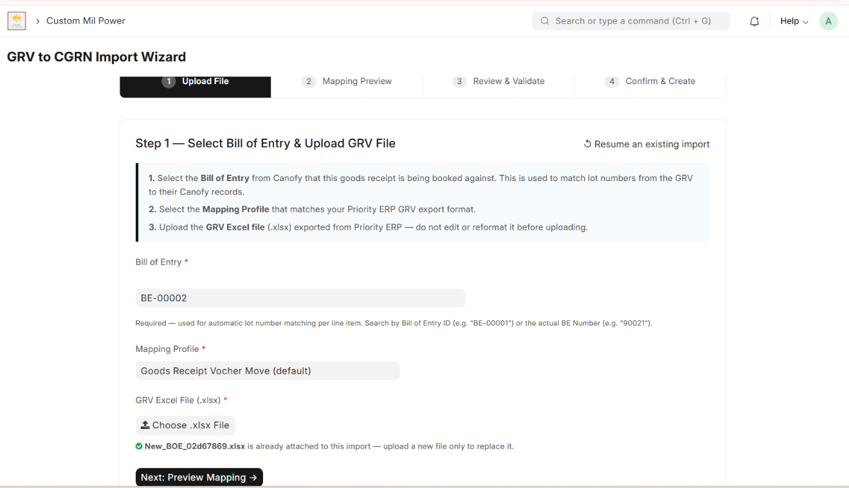
Figure 1: Step 1 – Upload GRV File

Step 2 — Mapping Preview
Verify that the wizard has correctly mapped Excel columns to CGRN fields. Check the sample values before proceeding.

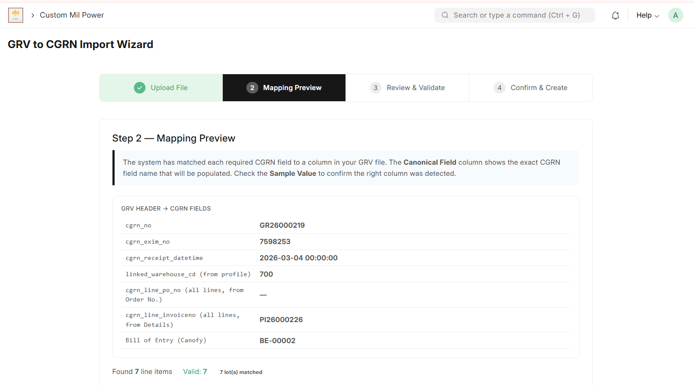
Figure 2: Step 2 – Mapping Preview

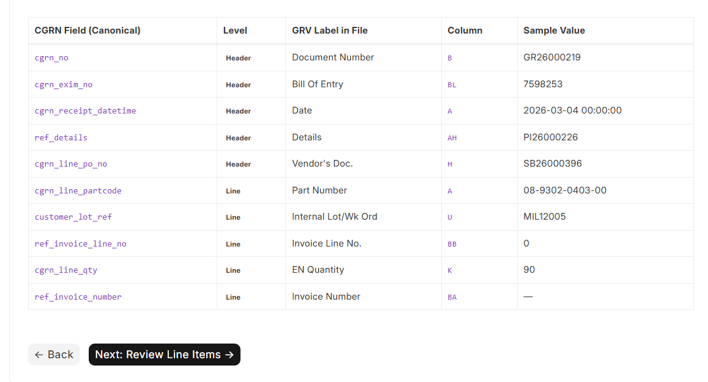

Step 3 — Review & Validate
Review all imported line items. Confirm the part number, quantity, invoice number, lot reference and lot match. Only valid rows should be included.
There are 3 optional fields: Vehicle No, One Time Lock No & Insurance Policy.

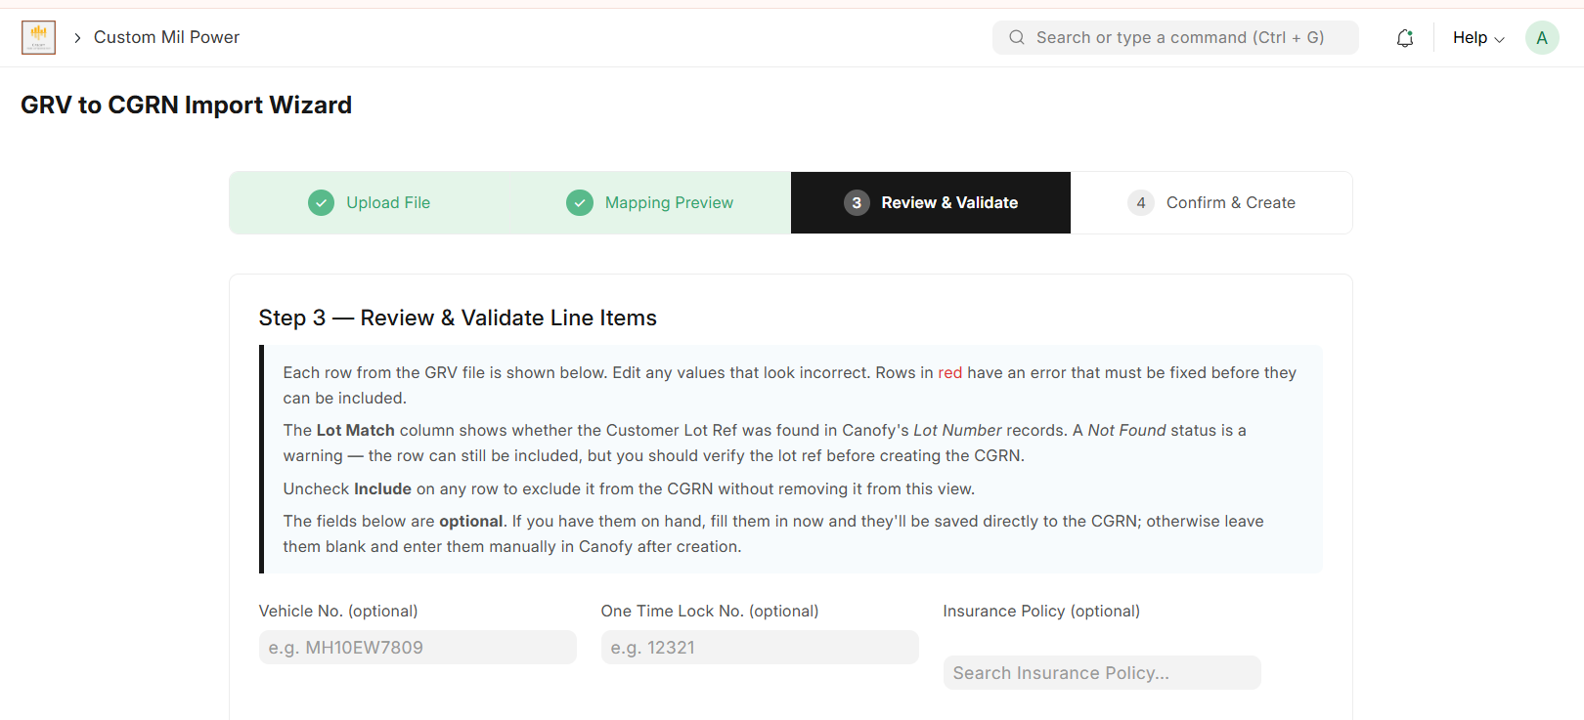
Figure 4: Step 3 – Review & Validate

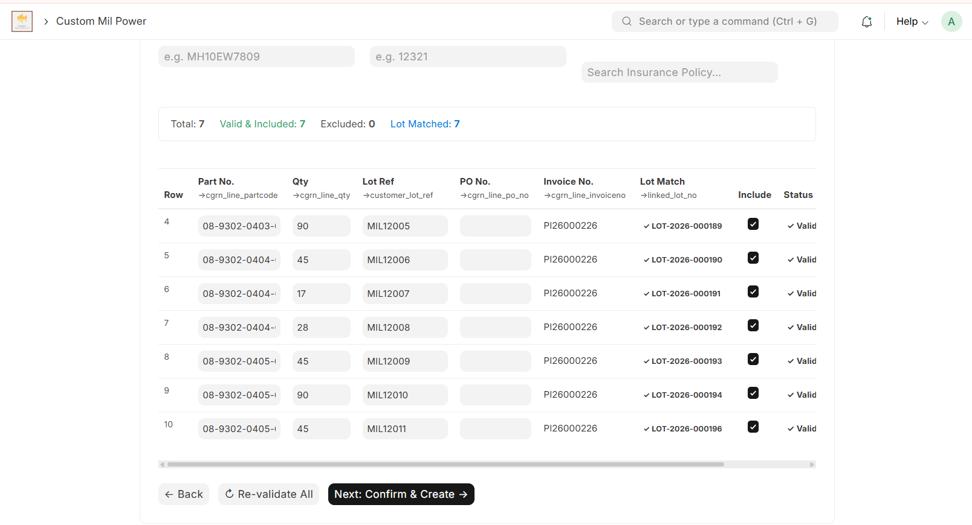

Step 4 — Confirm & Create
Review the import summary. Click Create CGRN to generate a Draft CGRN. Inventory is not updated until the CGRN is submitted. Click on the Create CGRN button.

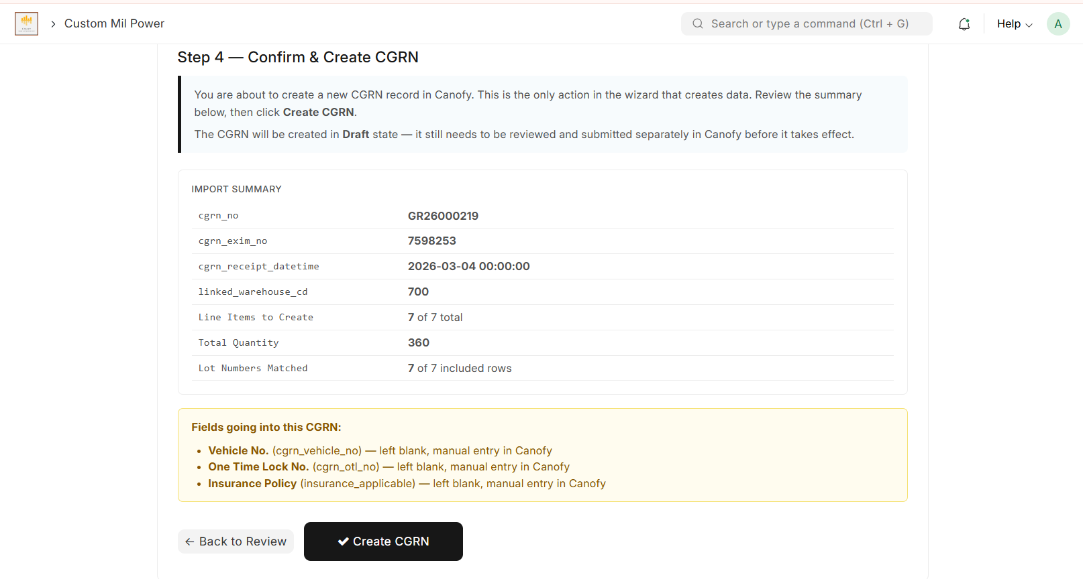
Figure 6: Step 4 – Confirm & Create

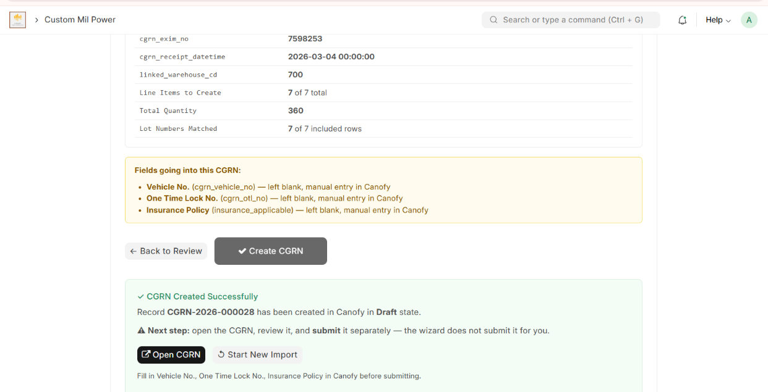

Once the CGRN is successfully created, click on the Open CGRN button to redirect to the CGRN page. To upload a new Excel file, click Start New Import.
Review Draft CGRN
Open the Draft CGRN, verify all details, review linked lot numbers and quantities, then submit the document to complete the process.

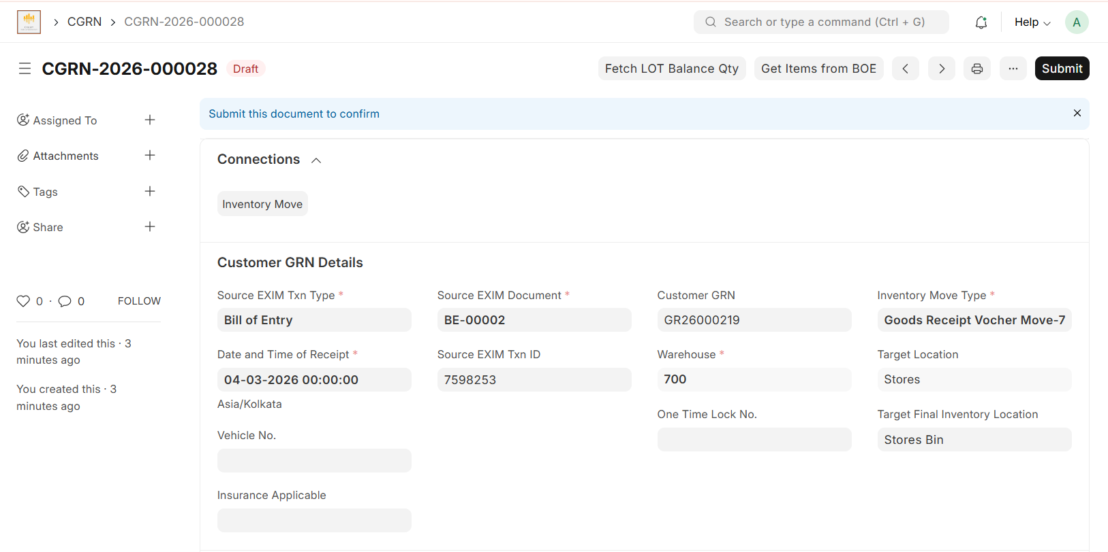
Figure 8: Review Draft CGRN

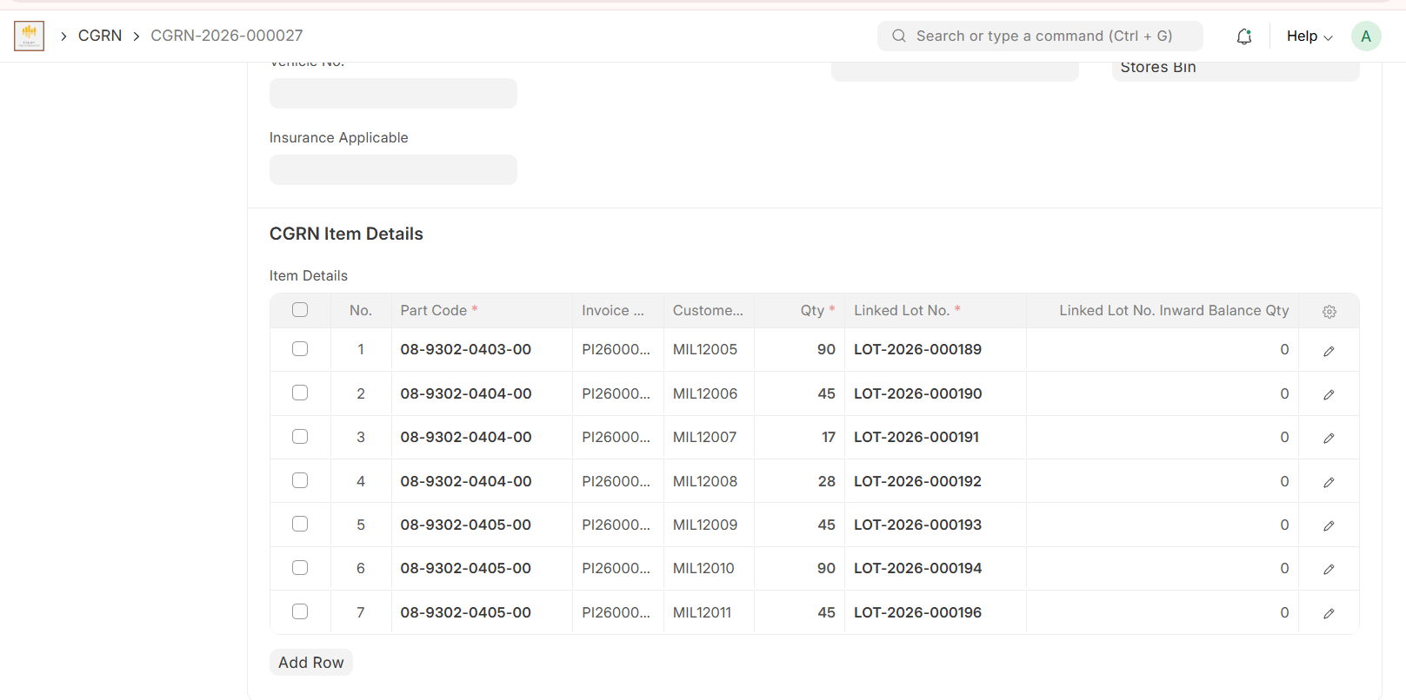

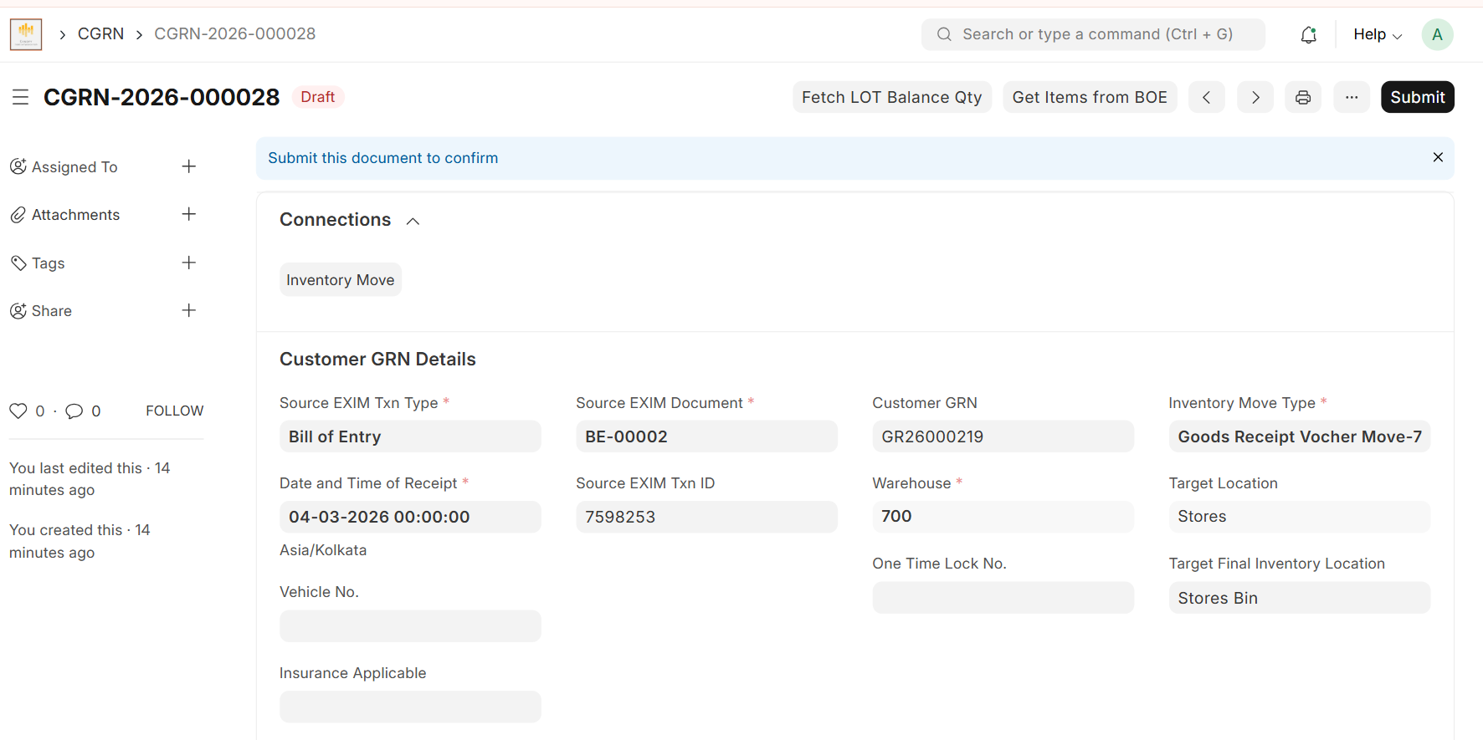

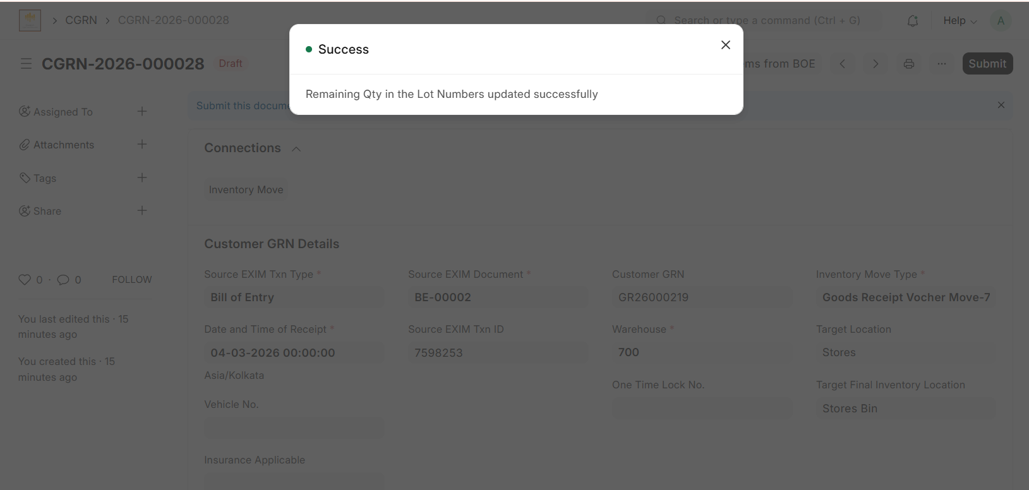

Once the CGRN is created it is in the Draft status, and Lot Numbers are not updated. Click on the button above, “Fetch LOT Balance Qty”, and the remaining quantity in the Lot Numbers is updated.

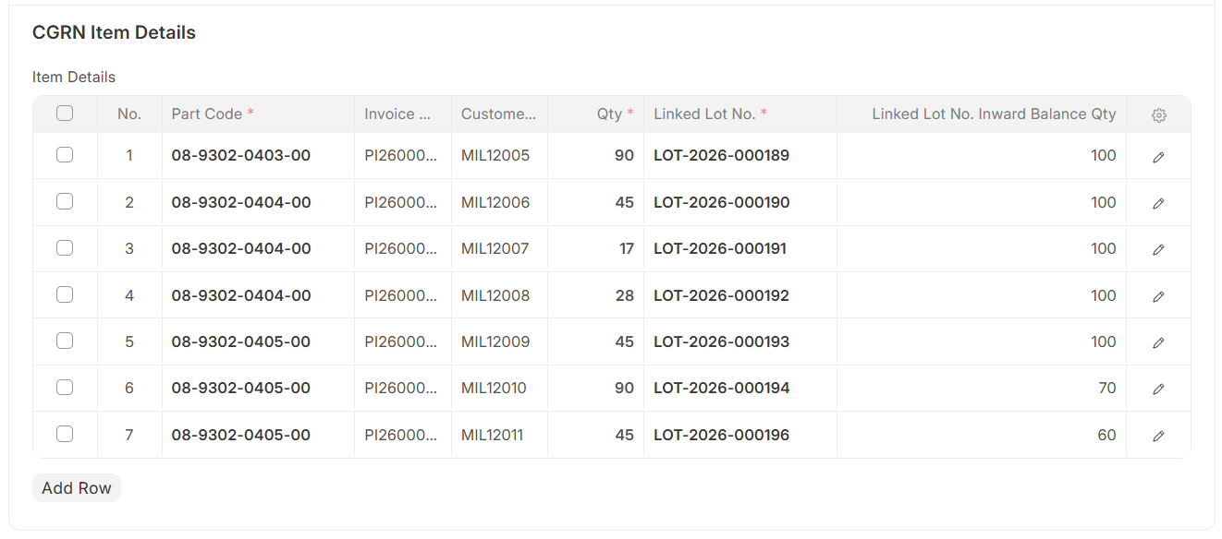

Best Practices
Recommendations
✓ Always use the original ERP Excel file.
✓ Verify the selected Bill of Entry.
✓ Review mapping before creating the CGRN.
✓ Verify all lot matches.
✓ Review the Draft CGRN before submitting.
✓ Click on “Fetch LOT Balance Qty” to update quantity, then click Submit.

