USER MANUAL
E – WAY BILL CREATION
STEP BY STEP GUIDE FOR CREATING E WAY BILL

E-Way Bill Creation
There are two ways to create an E-Way Bill:
- Using an E-Way Bill Request Template – Create and save a template first, then use it to create the E-Way Bill.
- Direct E-Way Bill Creation – Create the E-Way Bill directly without creating a template.
Before You Begin – Mandatory Setup
Before using either method, the following master data must be created:
- Business Partner
Note: Creating a Business Partner is mandatory before proceeding with either E-Way Bill creation method.

E-Way Bill Creation Workflow

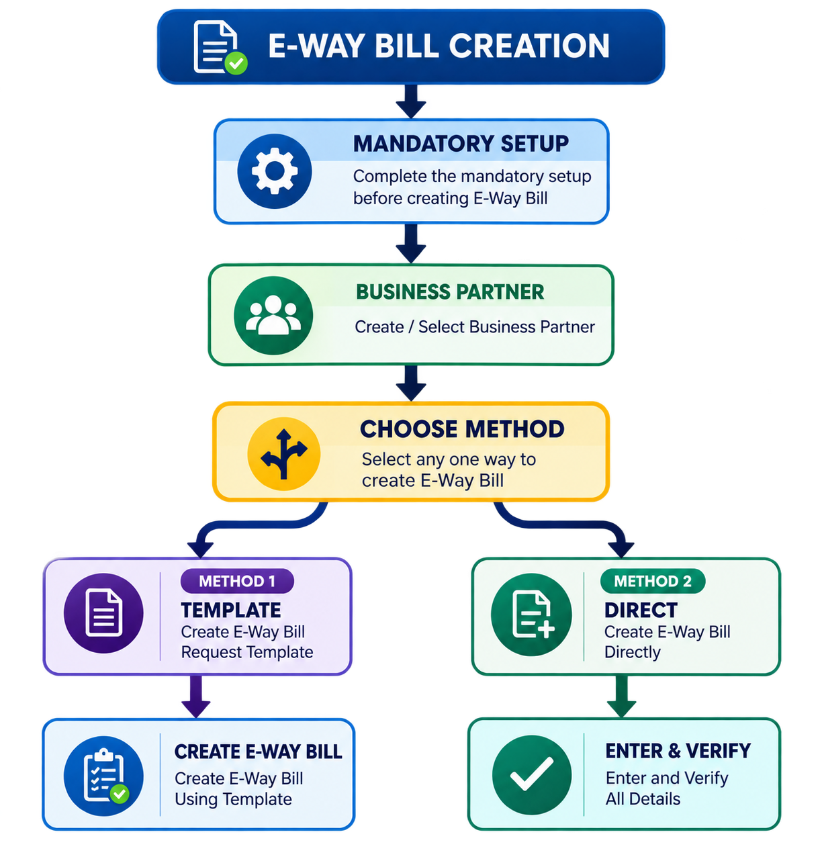

Mandatory Setup
Before creating an E-Way Bill, complete the following mandatory setup:
- Business Partner
Once this is created, you can proceed with either method of E-Way Bill creation.

Step 1: Create Business Partner Master
Let’s start by creating the Business Partner Master, which is mandatory before creating an E-Way Bill.

Create Business Partner Master
- In the Search bar, search for “Business Master Partner List” and select it.
- Click “+ Add Business Master Partner List”.
- Enter all required details:
  - Partner Name
  - Partner Code
  - Partner Category
  - CB Code
- Select the Partner Category accurately based on the Business Partner type.
- Verify that all entered details are correct.
- Click Save.
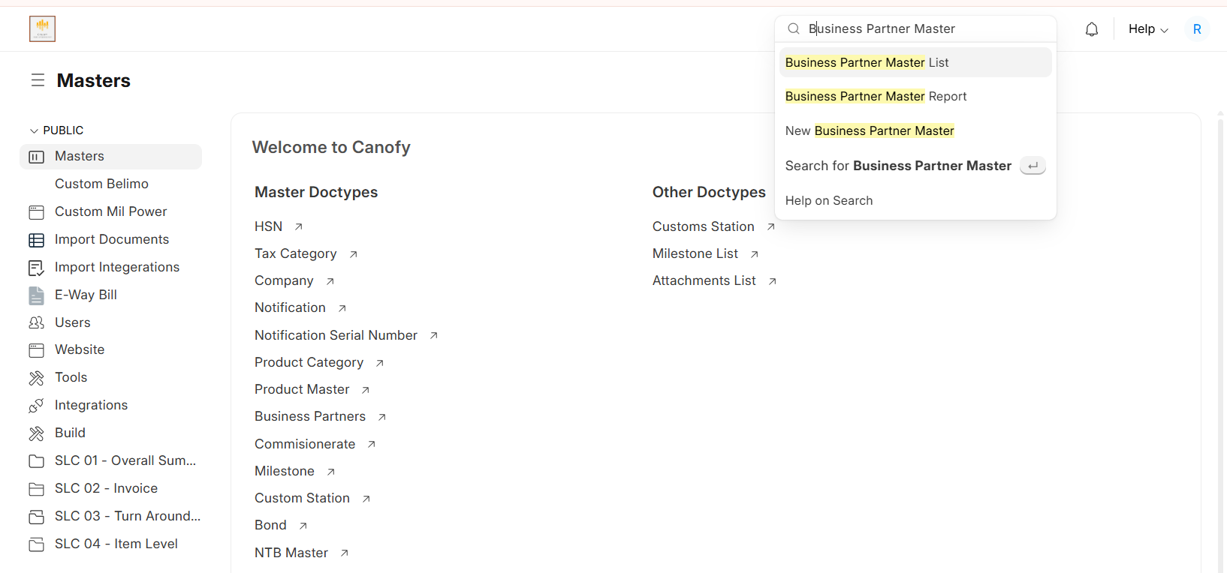
The Business Partner Master is now successfully created and can be used for E-Way Bill creation.

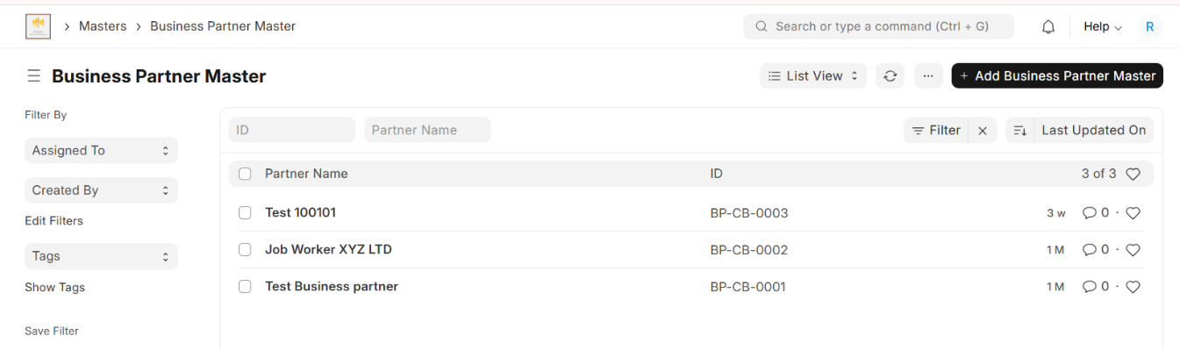
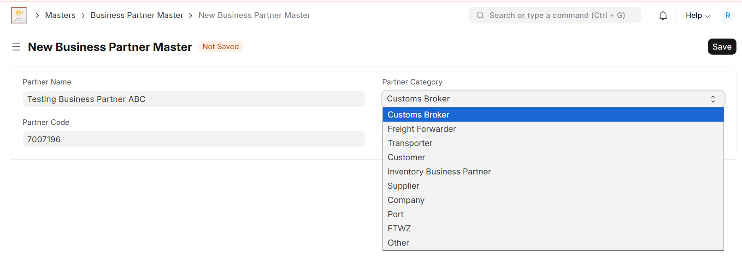
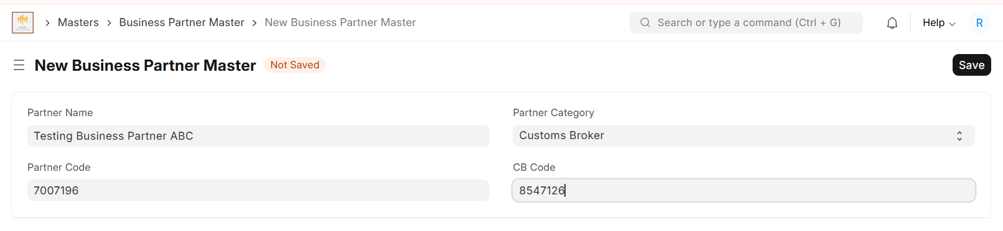

The Business Partner Master is now successfully created and can be used for E-Way Bill creation.

Method 1: Create E-Way Bill Using an E-Way Bill Request Template
Using an E-Way Bill Request Template makes E-Way Bill creation easier and faster. Once a template is created and saved, the template details can be automatically populated when creating an E-Way Bill. This reduces repetitive data entry and helps maintain consistency.
Step 1: Create an E-Way Bill Request Template
- From the application menu, search for E-Way Bill Request Template.
- Open E-Way Bill Request Template.
- Click + Add E-Way Bill Request Template.
- Enter all the required details carefully and accurately.
Important: The information entered in the template will be used later while creating the E-Way Bill. Verify all details before saving the template.

Template Details
Enter the following information:
1. Template Name
Enter a unique and meaningful name for the template so that it can be easily identified when creating an E-Way Bill.
Example: Regular Outward Supply – ABC Company
2. Company
Select the company for which the E-Way Bill will be created.
3. Company Address
Select the appropriate company address associated with the selected company.
4. Requestor Type
Select the person/entity requesting the E-Way Bill:
- Tax Payer – Select when the E-Way Bill request is created by the taxpayer/business.
- Transporter – Select when the E-Way Bill request is created by the transporter.
5. Supply Type
Select the direction of the supply:
- Outward – Goods are being supplied or dispatched from the supplier.
- Inward – Goods are being received by the recipient.
Select the option that correctly represents the movement of goods.
6. Sub Type
Select the reason or nature of the goods movement, such as:
- Supply
- Import
- Export
- Job Work
- For Own Use
- Sales Return
- Others
Select the option that accurately describes the transaction.
7. Transaction Type
Select the transaction type based on the billing and delivery arrangement:
- Regular – Bill From and Dispatch From are the same, and Bill To and Ship To are the same.
- Bill To – Ship To – Goods are billed to one party but delivered to another.
- Bill From – Dispatch From – Goods are billed from one party but physically dispatched from another location.
- Combination – Both Bill To – Ship To and Bill From – Dispatch From apply.
8. Document Type
Select the document supporting the movement of goods, such as:
- Tax Invoice
- Bill of Supply
- Bill of Entry
- Delivery Challan
- Others
Select the document type that matches the transaction.
9. Consolidate Items by HSN
Enable this option when items need to be consolidated based on their HSN code, as applicable to your transaction.

Billing Parties Information
Enter the billing details for the parties involved in the transaction.
10. Bill From
Select the supplier/party from whom the goods are billed.
11. Bill From Address
Select the appropriate billing address of the Bill From party.
12. Bill To
Select the customer/recipient to whom the goods are billed.
13. Bill To Address
Select the appropriate billing address of the Bill To party.

Shipping Parties Information
Enter the actual dispatch and delivery details.
14. Dispatch From
Select the location from which the goods are physically dispatched.
This may be different from the Bill From party/location depending on the transaction type.
15. Dispatch From Address
Select the actual address from which the goods will be dispatched.
16. Ship To
Select the party/location where the goods will actually be delivered.
This may be different from the Bill To party depending on the transaction type.
17. Ship To Address
Select the actual delivery address where the goods will be received.

Transporter Details
Enter the information related to transportation of the goods.
18. Transporter
Select the transporter responsible for transporting the goods.
19. Approximate Distance (in km)
Enter the approximate transportation distance in kilometres from the source location to the destination.
Ensure that the distance entered is appropriate for the actual movement of the goods.

Part-B Details
Enter the details required for transportation of the goods.
20. Transporter Mode
Select the mode of transportation used for the movement of goods, such as:
- Road
- Rail
- Air
- Ship
- In Transit
Select the mode that matches the actual transportation method.
21. Vehicle Type
Select the appropriate vehicle type:
- Regular – Select for normal transportation using a regular vehicle.
- Over Dimensional Cargo (ODC) – Select when the goods are being transported as Over Dimensional Cargo.
Select the vehicle type according to the actual transportation of the goods.

Step 2: Verify and Save the Template
After completing all the fields:
- Review all entered details carefully.
- Verify the Company, Supply Type, Sub Type, Transaction Type, Document Type, Billing Parties, Shipping Parties, Transporter, Distance, Transporter Mode, and Vehicle Type.
- Correct any incorrect or missing information.
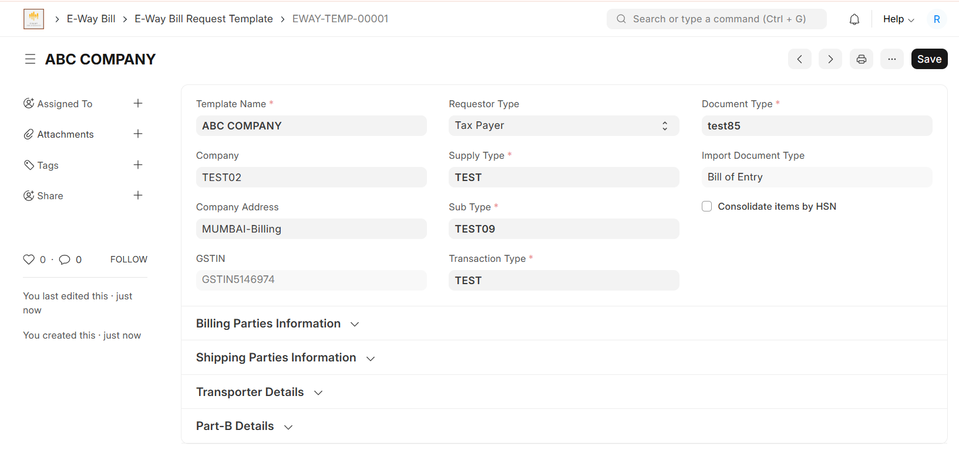
- Click Save.

The E-Way Bill Request Template is now successfully created.
The saved template can be selected during E-Way Bill creation, and the relevant information will be automatically populated from the template, making the E-Way Bill creation process faster and reducing repetitive data entry.
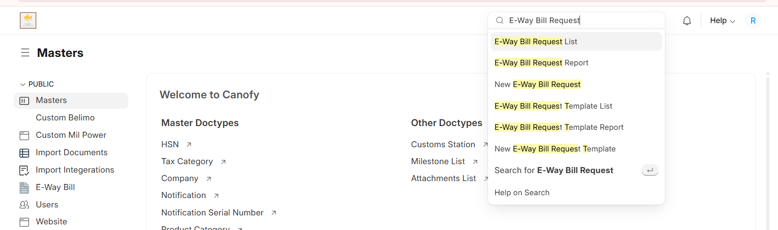
Important: Always verify the template information before saving. Any incorrect information saved in the template may be automatically carried forward when creating an E-Way Bill.
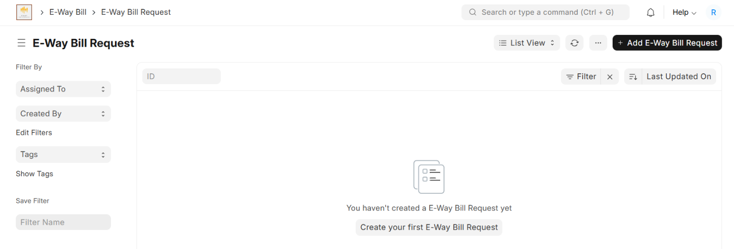
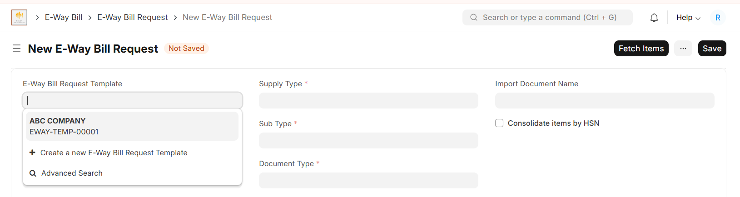
Step 2: Create E-Way Bill Using the Saved Template
Once the E-Way Bill Request Template has been created, it can be used to create an E-Way Bill Request. The saved template automatically populates the relevant details, reducing manual data entry.
1. Open E-Way Bill Request
- In the Search bar, search for “E-Way Bill Request List”.
- Open E-Way Bill Request List.
- Click + New E-Way Bill Request.
2. Select the E-Way Bill Request Template
- Locate the E-Way Bill Request Template field.
- Click the field to open the dropdown list.
- Select the template that you created earlier.
Once the template is selected, the details saved in the template will be automatically populated in the E-Way Bill Request form.
Important: Do not assume that the automatically populated information is correct. Carefully review all the details before proceeding.

3. Verify the Automatically Populated Details
After selecting the template, verify the following sections:
Request and Company Details
Check:
- Requestor Type
- Company
- Company Address
- GSTIN
- Supply Type
- Sub Type
- Document Type
- Transaction Type
- Import Document Type – where applicable
- Import Document Name – where applicable
- Consolidate Items by HSN – where applicable
Billing Parties Information
Verify:
- Bill From
- Bill From Address
- Bill To
- Bill To Address
Shipping Parties Information
Verify:
- Dispatch From
- Dispatch From Address
- Ship To
- Ship To Address
Transporter Details
Verify:
- Transporter
- Transporter Name
- Approximate Distance (in km)
Part-B Details
Verify:
- Transporter Mode
- Vehicle Number
- Vehicle Type
- Transport Receipt No
- Transport Receipt Date
Make sure that all information is accurate and corresponds to the actual movement of goods.

4. Verify the Totals
Before saving the E-Way Bill Request, carefully verify the Totals section.
Check:
- CGST Amount
- SGST Amount
- IGST Amount
- CESS Advol Amount
- CESS Non-Advol Amount
- Total Taxable Value
- Other Amount
- Total Invoice Amount
Ensure that the amounts are correct and match the applicable invoice/document.

5. Mandatory Fields
The following fields are mandatory in the E-Way Bill Request:
- Bill From GSTIN
- Bill From State
- Bill To GSTIN
- Bill To State
Ensure that all four fields are correctly populated before saving the document.
After the template details are automatically populated:
- Go to the Import Document Name field.
- Click the field to open the dropdown list.
- Select the correct Bill of Entry corresponding to the transaction.
- Verify that the selected Bill of Entry Number is accurate before proceeding.
Important: Make sure you select the correct Bill of Entry from the dropdown, as the selected document will be used for fetching the relevant item details.

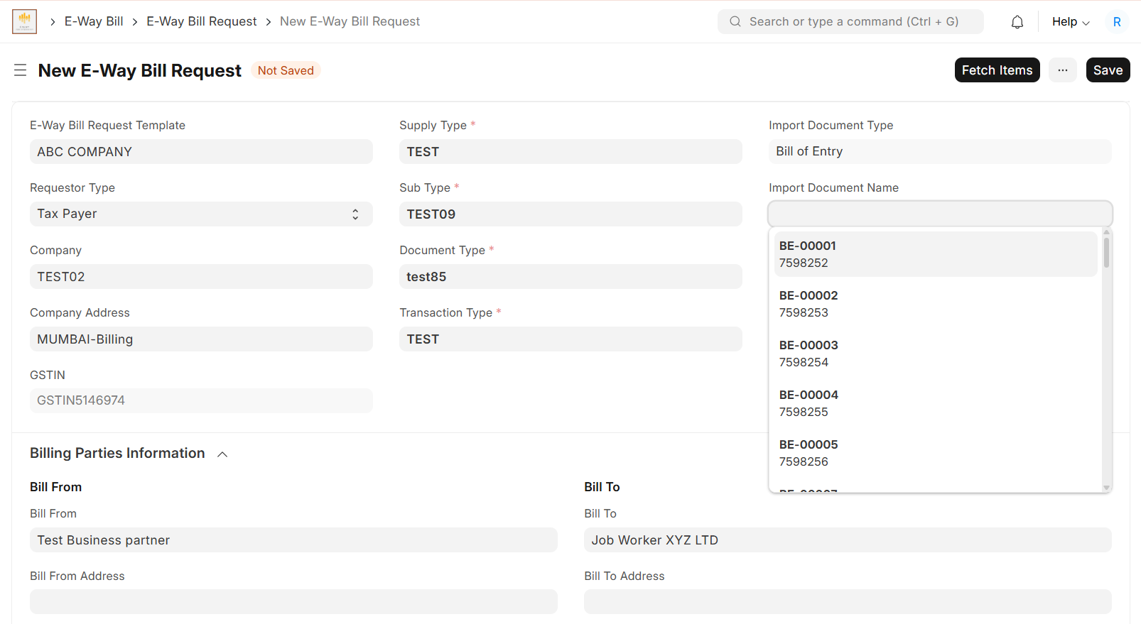

Important: Bill From Address & Bill To Address
Bill From Address and Bill To Address are important fields and must be verified carefully.
- Bill From Address: Select the correct address of the party from whom the goods are billed.
- Bill To Address: Select the correct address of the party to whom the goods are billed.
Important: Ensure that both addresses are correct and correspond to the selected Bill From and Bill To parties before saving the E-Way Bill Request.
6. Save the E-Way Bill Request
After verifying all the details:
- Click Save.
- Wait for the document to save successfully.
- The status of the New E-Way Bill Request will change to Saved.
Important: You must save the E-Way Bill Request before clicking “Fetch Items.”

7. Fetch Items
After the document has been successfully saved:
- Click Fetch Items.
- The applicable item details will be automatically retrieved and populated in the Items section.
- Wait until all the items are fetched.

8. Verify the Fetched Items
After the items are populated, carefully cross-check each item.
Verify:
- Product Name
- Description
- HSN
- Quantity
- Available Quantity
- Other applicable item details
Ensure that the fetched items correspond to the actual invoice/document and that no required item is missing or incorrect.

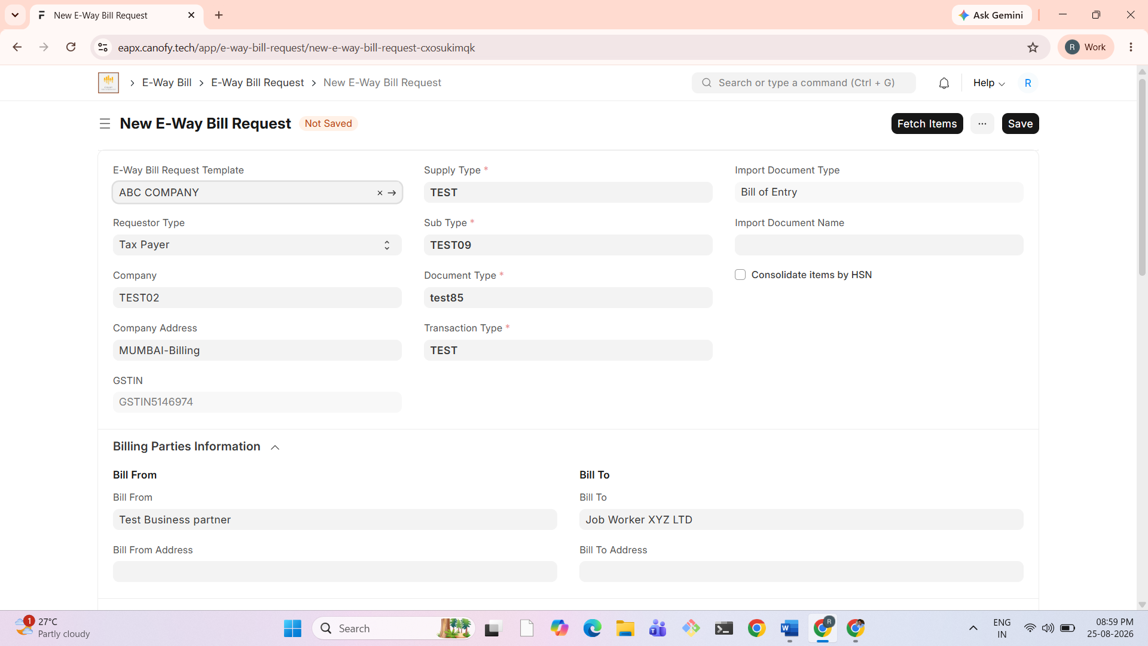
9. E-Way Bill Request Successfully Created
Once:
- The template details are verified,
- Mandatory fields are completed,
- The E-Way Bill Request is saved,
- Items are successfully fetched, and
- All item details are cross-verified,
the E-Way Bill Request is successfully prepared and is ready for the next stage of E-Way Bill processing.
Important: Always verify the automatically populated template data, totals, mandatory fields, and fetched item details before proceeding. The template reduces manual entry, but the user is responsible for ensuring that the final information is accurate.
Important: Always save the document first and then click “Fetch Items.” Do not attempt to fetch items before saving the E-Way Bill Request.

Validate the E-Way Bill Request
After clicking Fetch Items, the item details will be populated in the Items section.
- Verify that all the required items have been successfully fetched.
- Carefully cross-check the Product Name, Description, HSN, Quantity, and other item details.
- Once all the item details are verified, click Validate E-Way Bill Request.
Important: The Validate E-Way Bill Request button becomes available after the items are fetched. Always verify the fetched items before clicking this button.
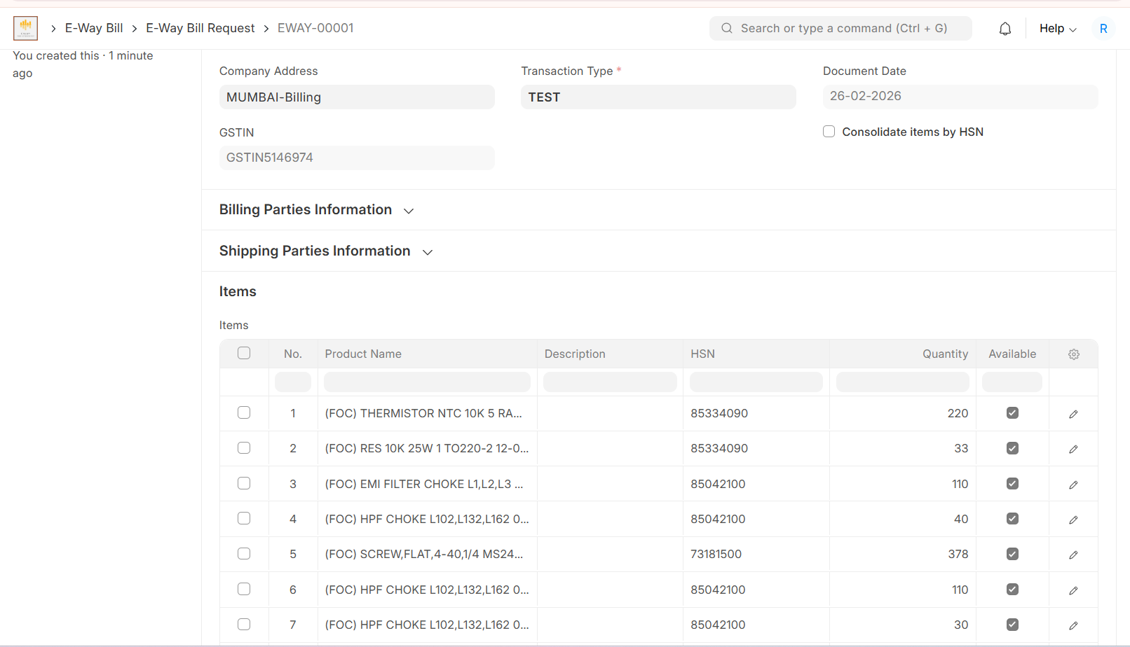
Validate and Complete E-Way Bill Creation
After verifying all the fetched item details, click Validate E-Way Bill Request.
- If all the details are correct, the E-Way Bill Request will be successfully validated, and the E-Way Bill creation process will be completed.
- If any error is found, the document status will change to Error. Review the error, correct the relevant details, and click Validate E-Way Bill Request again.
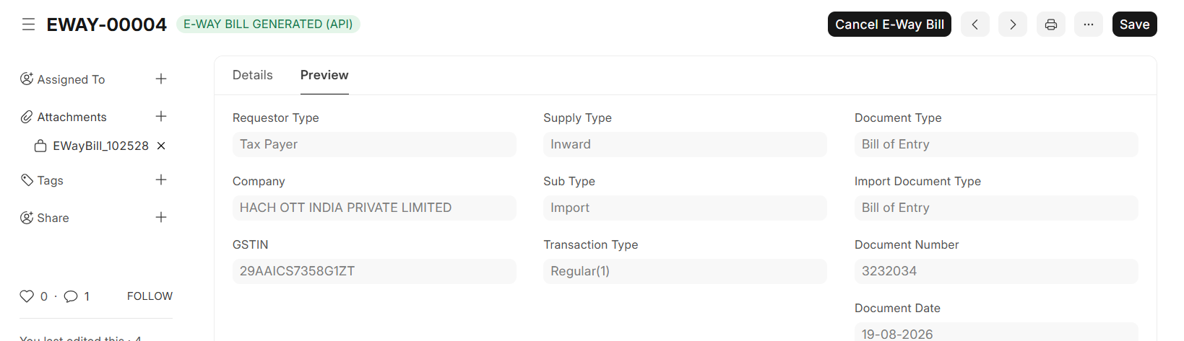
- Once the request is successfully validated, a Cancel button will appear. If you need to cancel the validated E-Way Bill Request, click Cancel.
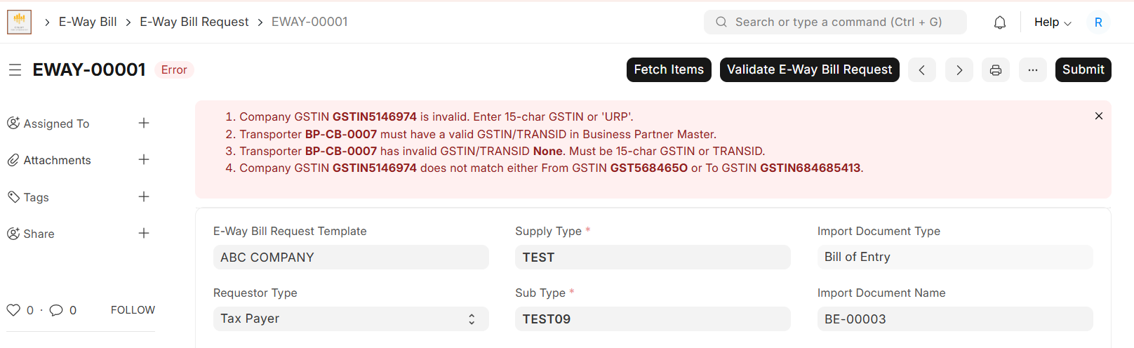
Important: Always resolve all errors and successfully validate the request before considering the E-Way Bill creation

Step 11: Generate E-Way Bill and Review Details
Once the E-Way Bill Request has been successfully validated:
- A Generate E-Way Bill button will appear.
- Click Generate E-Way Bill.
- The system will call the E-Way Bill API and submit the request to the E-Way Bill Portal.
- Once the E-Way Bill is successfully generated, the E-Way Bill Number and E-Way Bill PDF will be made available in the Preview tab.
- Open the Preview tab.
- Scroll down to the E-Way Bill Details section.
- Verify the generated E-Way Bill Number and review the available E-Way Bill PDF.
Important: Generate the E-Way Bill only after the request has been successfully validated. Verify the E-Way Bill Number and PDF in the Preview tab after successful generation.

Image for Generate E-Way Bill

Method 2: Create E-Way Bill Directly
In this method, you can create the E-Way Bill Request directly without using an E-Way Bill Request Template.
Since no template is being used, you must manually enter and verify all the required details in the E-Way Bill Request form.
Step 1: Create a New E-Way Bill Request
- In the Search bar, search for “E-Way Bill Request List”.
- Open E-Way Bill Request List.
- Click + New E-Way Bill Request

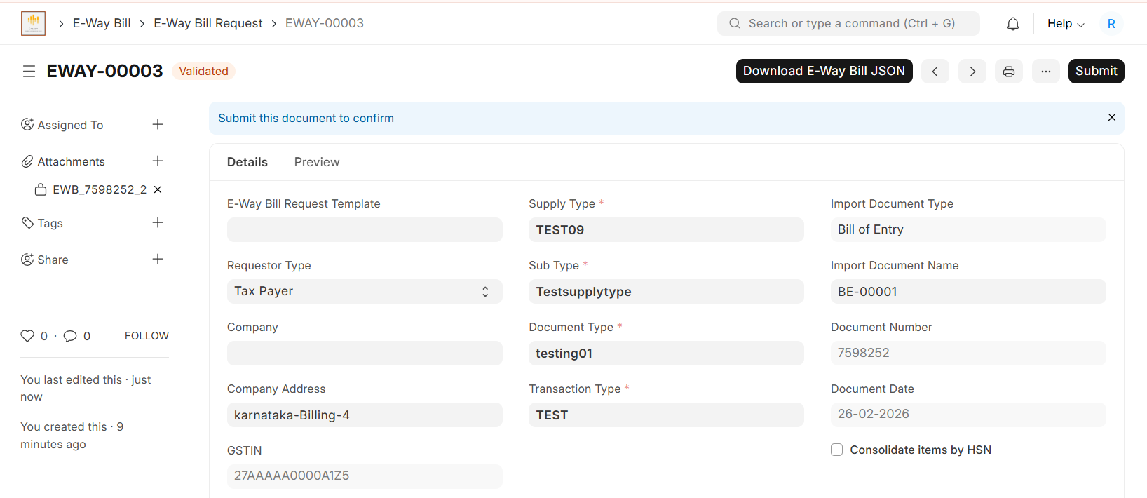
Step 2: Leave the Template Field Empty
In the E-Way Bill Request Template field:
Leave this field empty.
Since this method does not use a template, do not select any template from the dropdown.

Step 3: Enter the Required Details
Manually enter all the required information in the E-Way Bill Request form.
Request and Company Details
Enter and verify:
- Requestor Type
- Company
- Company Address
- GSTIN
- Supply Type
- Sub Type
- Document Type
- Transaction Type
- Import Document Type – where applicable
- Import Document Name – where applicable
- Consolidate Items by HSN – where applicable
Billing Parties Information
Enter:
- Bill From
- Bill From Address
- Bill To
- Bill To Address
Important: Bill From Address and Bill To Address must be selected accurately and should correspond to the respective Business Partners.
Shipping Parties Information
Enter:
- Dispatch From
- Dispatch From Address
- Ship To
- Ship To Address
Transporter Details
Enter:
- Transporter
- Transporter Name
- Approximate Distance (in km)
Part-B Details
Enter:
- Transporter Mode
- Vehicle Number
- Vehicle Type
- Transport Receipt No
- Transport Receipt Date
For Vehicle Type, select the appropriate option:
- Regular
- Over Dimensional Cargo (ODC)
Step 4: Verify All Details
Since no template is being used, all information must be entered manually.
Before saving, carefully verify:
- Company and GSTIN
- Supply and transaction details
- Bill From and Bill To details
- Bill From and Bill To addresses
- Dispatch From and Ship To details
- Transporter details
- Transport mode and vehicle details
- Import document details, where applicable
The following fields are mandatory:
- Bill From GSTIN
- Bill From State
- Bill To GSTIN
- Bill To State
Image for Generate Eway Bill

Step 5: Save the E-Way Bill Request
After entering and verifying all details:
- Click Save.
- Confirm that the document status changes to Saved.
- Only after saving, click Fetch Items.
- Verify all fetched item details.
- Click Validate E-Way Bill Request.
- Resolve any errors if displayed and validate again.
- Once successfully validated, proceed with Generate E-way BILL and then Click Submit
- Important: In Method 2, the E-Way Bill Request Template field must remain empty because the E-Way Bill Request is being created directly. Unlike Method 1, no information will be automatically populated from a template, so the user must ensure that every required field is entered correctly.
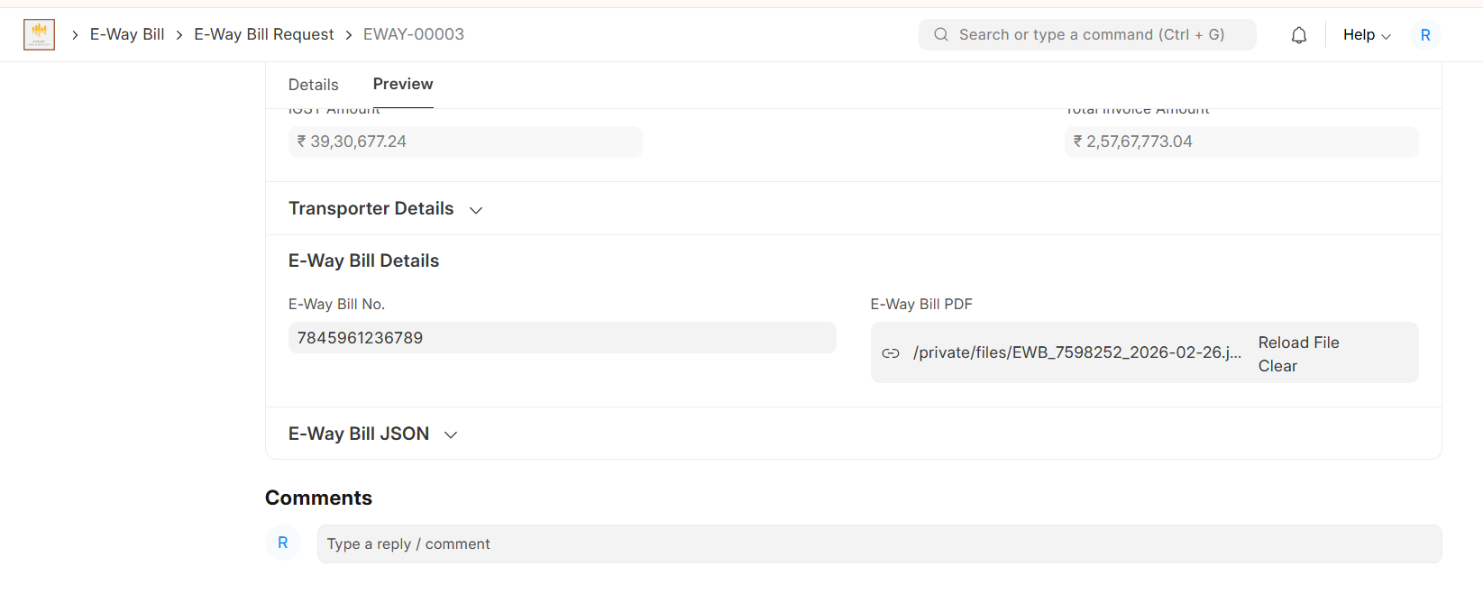

Sample E-Way Bill PDF
The downloaded E-Way Bill PDF will appear in the format shown in the sample below.
Use the sample PDF as a reference to understand the layout, fields, and information displayed on the generated E-Way Bill




